Mechanical Shop Management System

Test Output

**Name**

1. Paphop Manakamjorn 000948992

2. Andrew Le 000798003

# Add a New Customer

Customer page before adding a new client

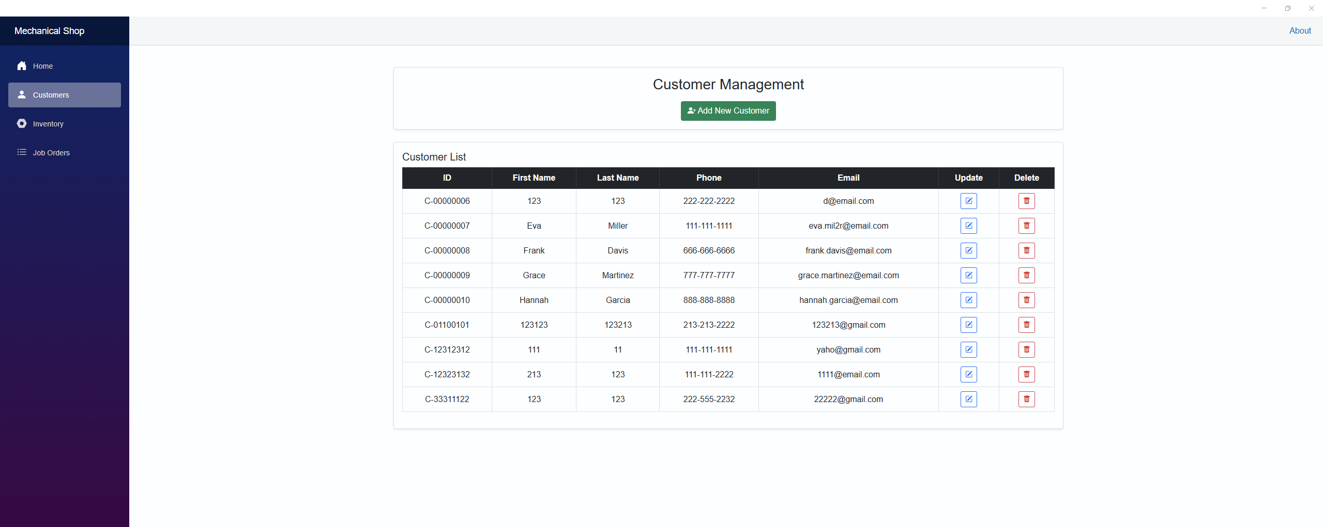

Adding a new client

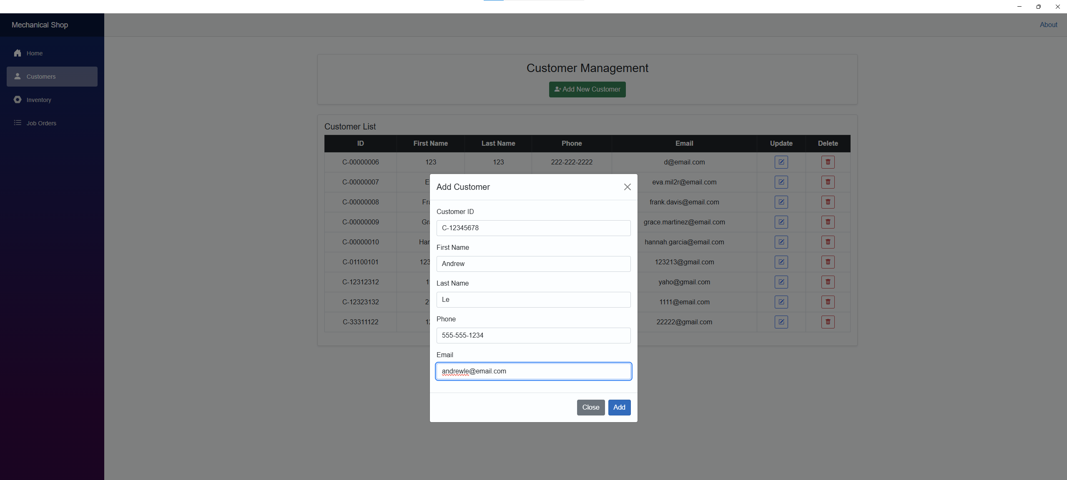

Customer page after adding a new client

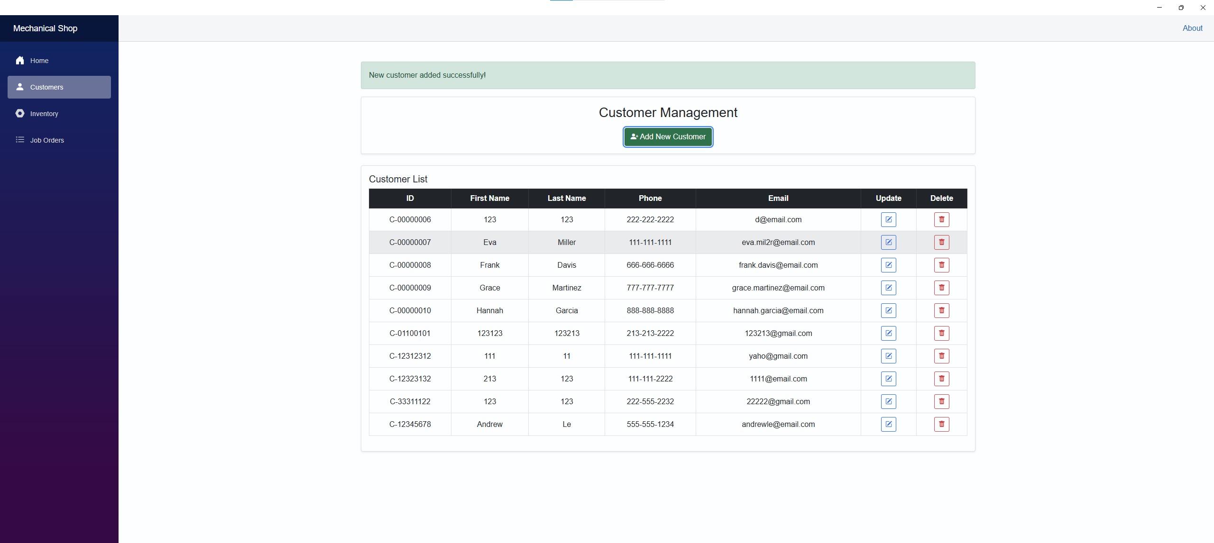

# Update the Information of An Existing Customer

Customer page before updating information of an existing customer

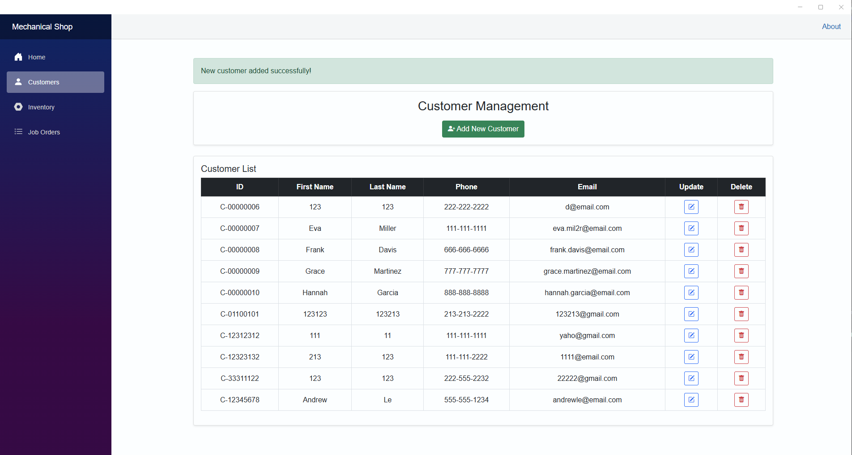

Update page

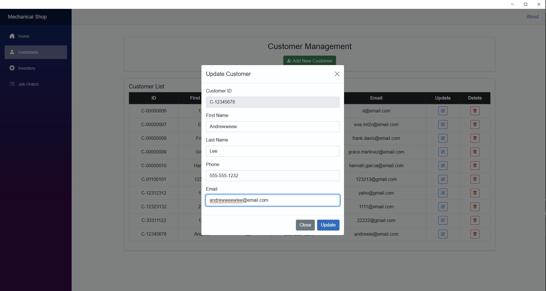

Customer page after updating information of an existing customer

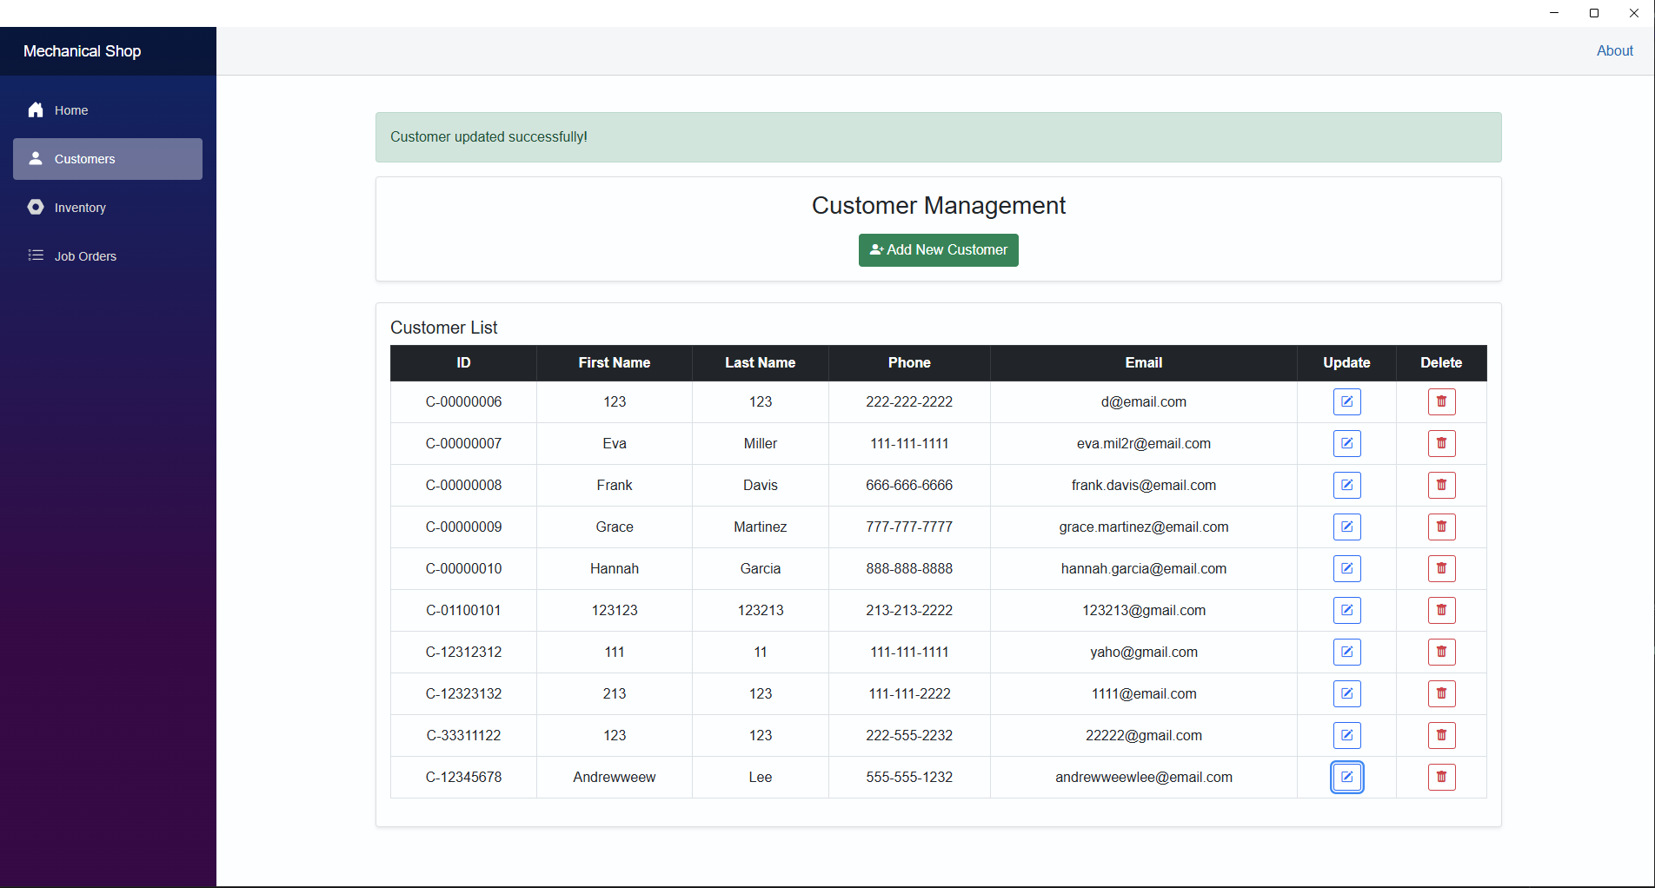

Delete an Existing Customer

Customer page before deleting an existing customer

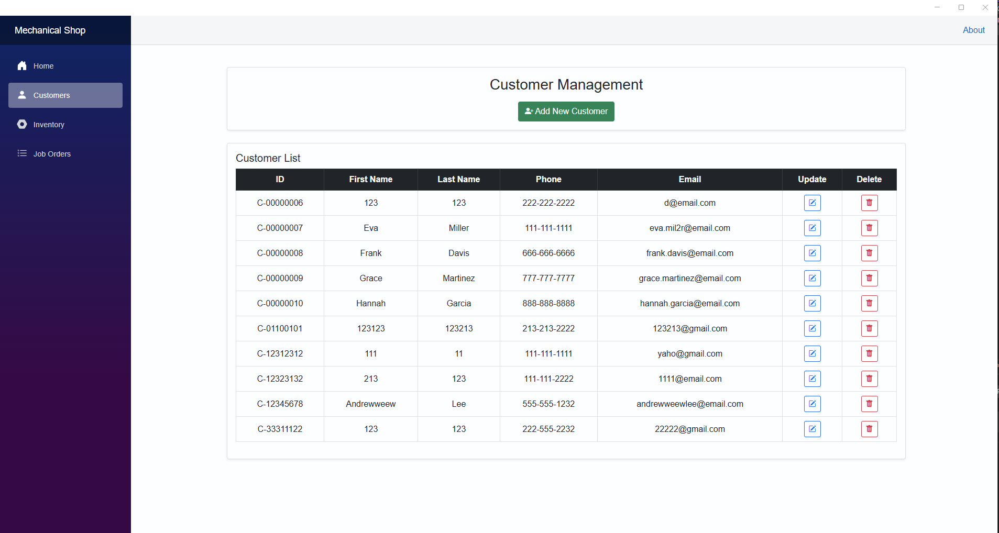

Customer page after deleting an existing customer (Delete customer #C-12345678)

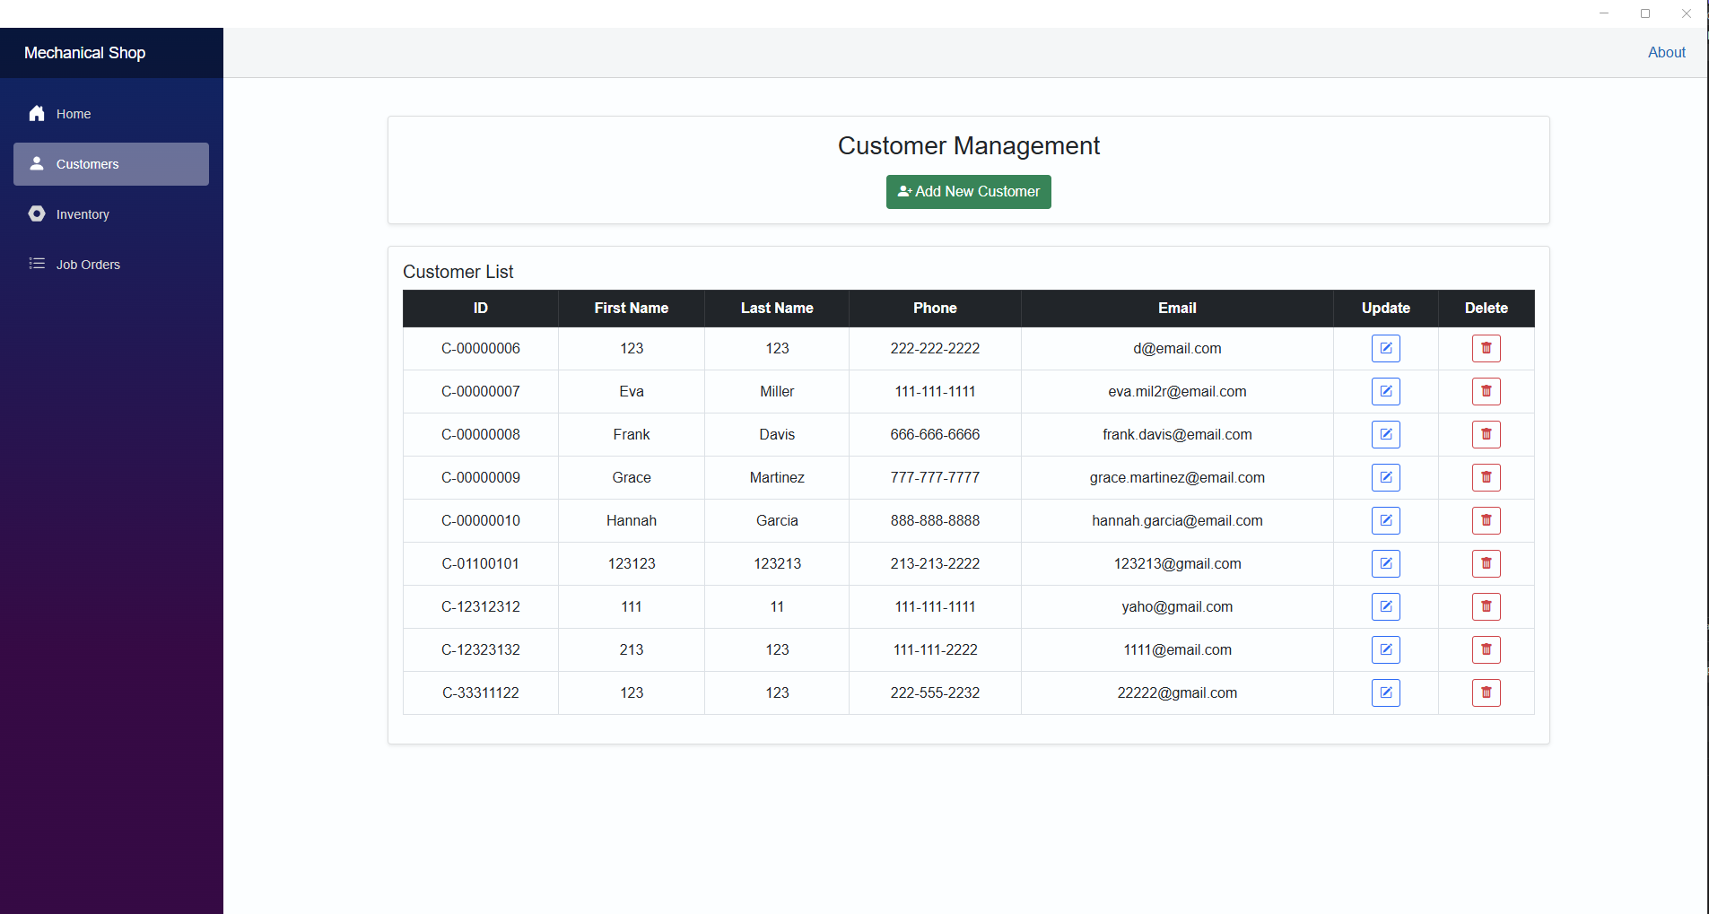

Error Detection in Customer Page

All fields are required to fulfill

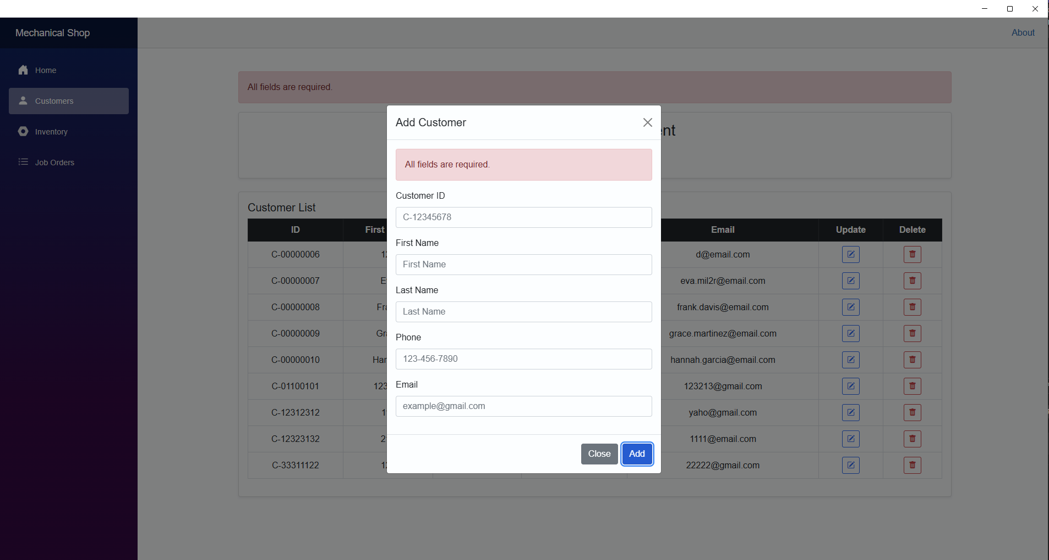

Customer ID must be entered in the following format: C-########

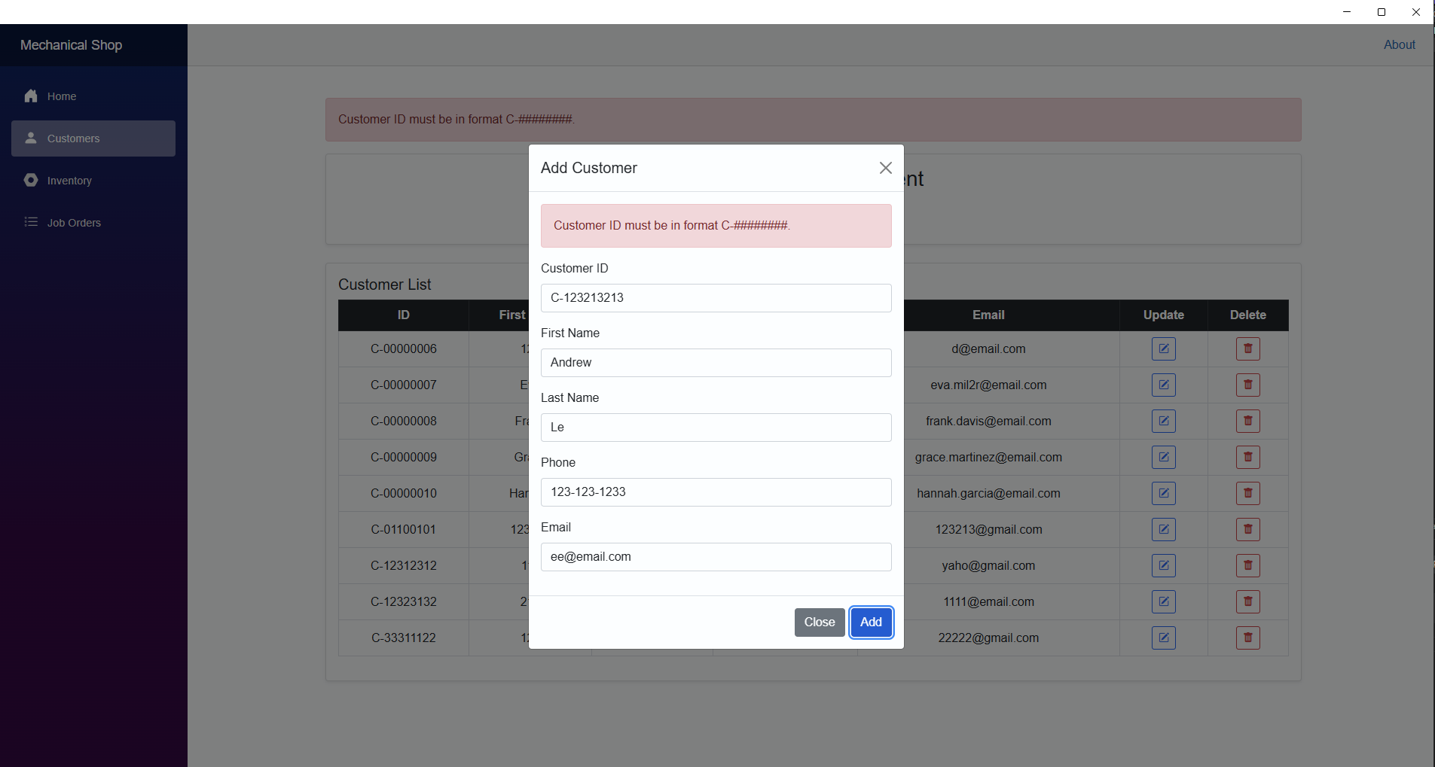

Phone number must be in format: ###-###-####

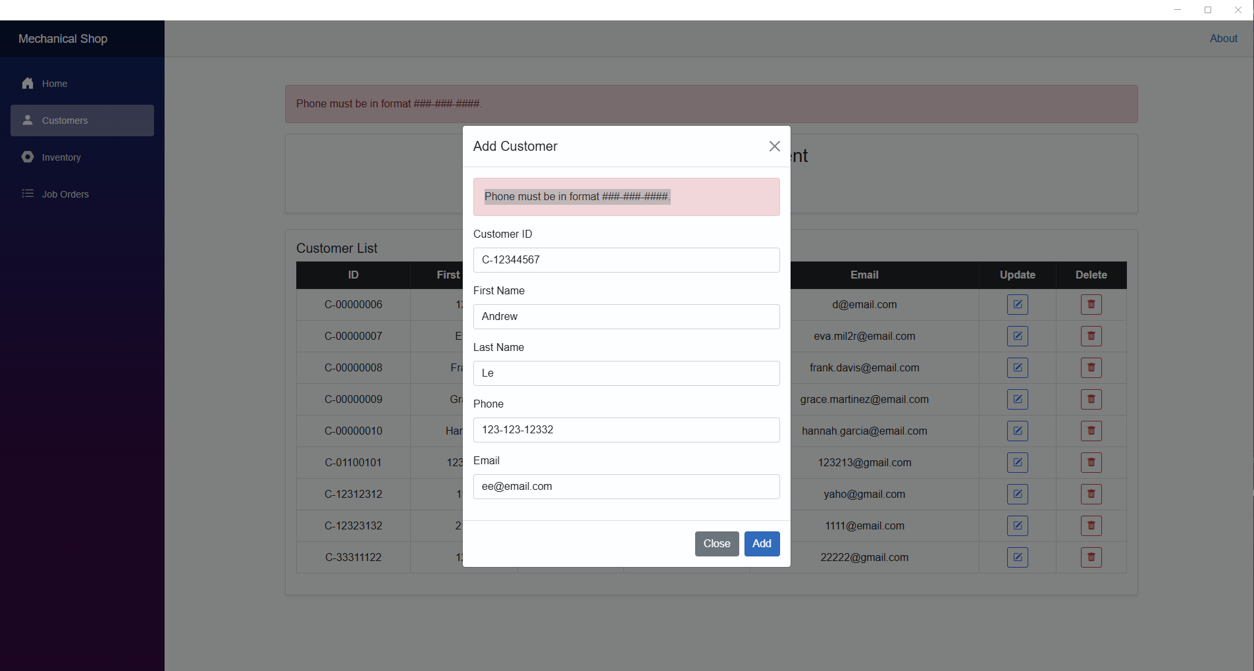

Email must end with @email.com

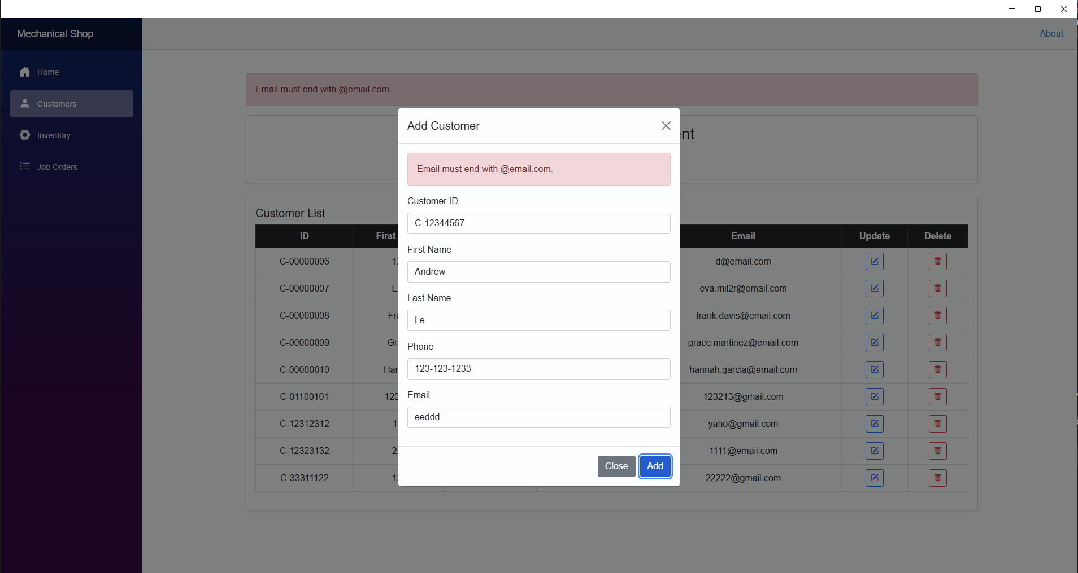

Duplicated customer ID

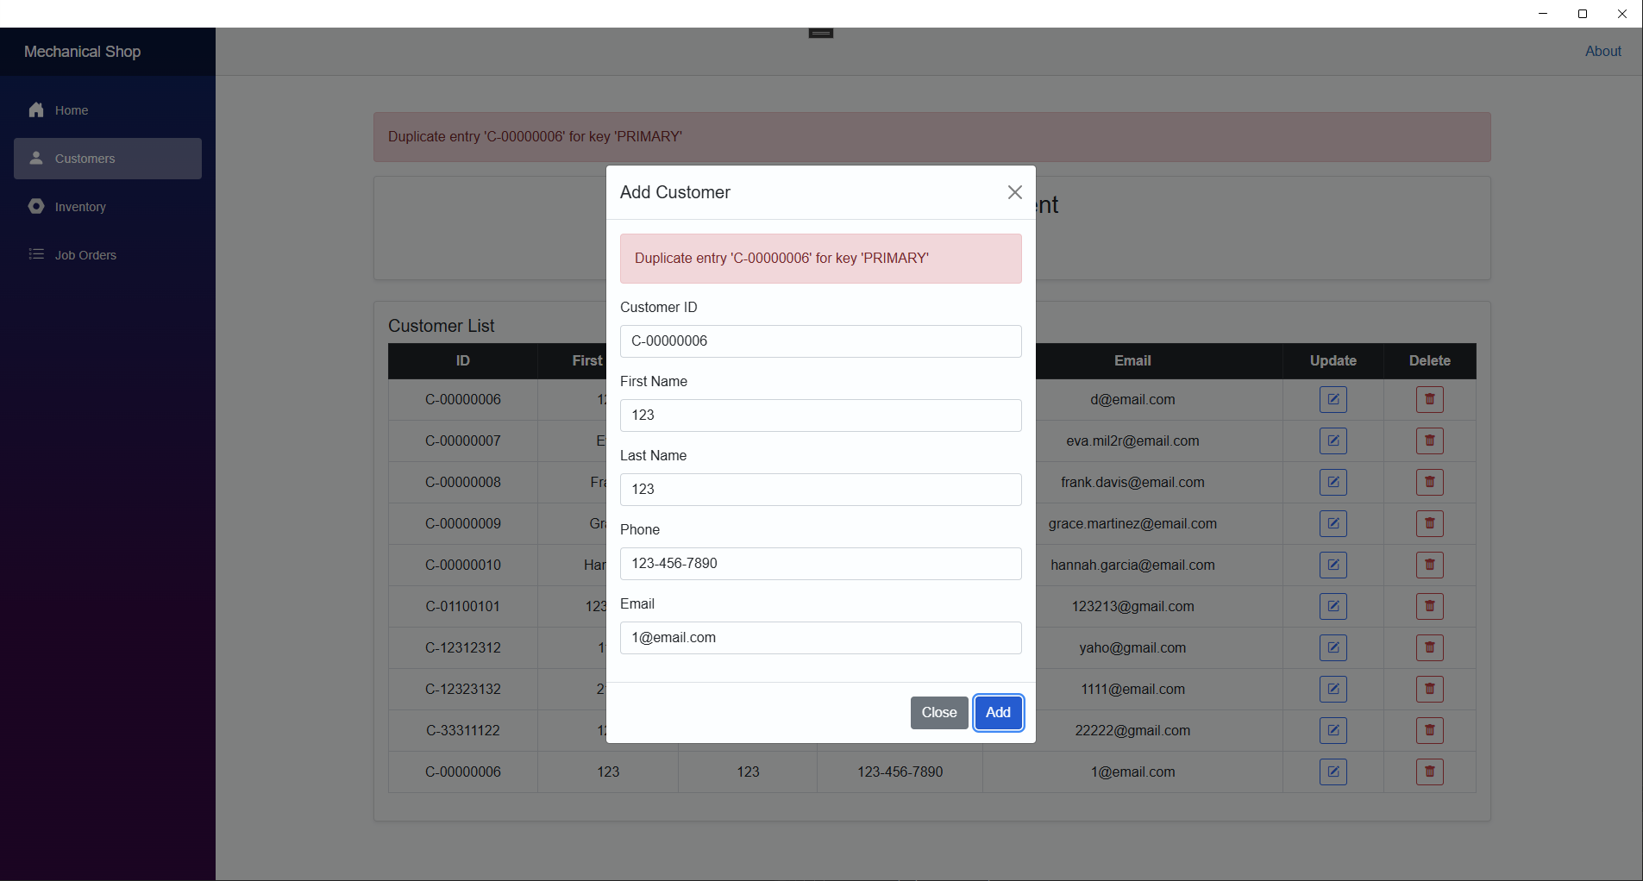

# Add New Equipment

Inventory page before adding new equipment

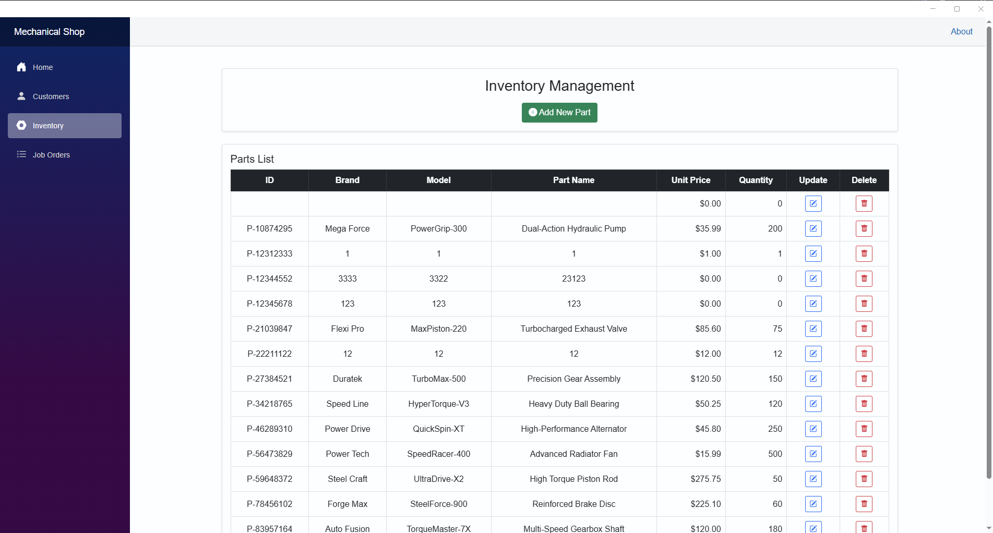

Add new equipment

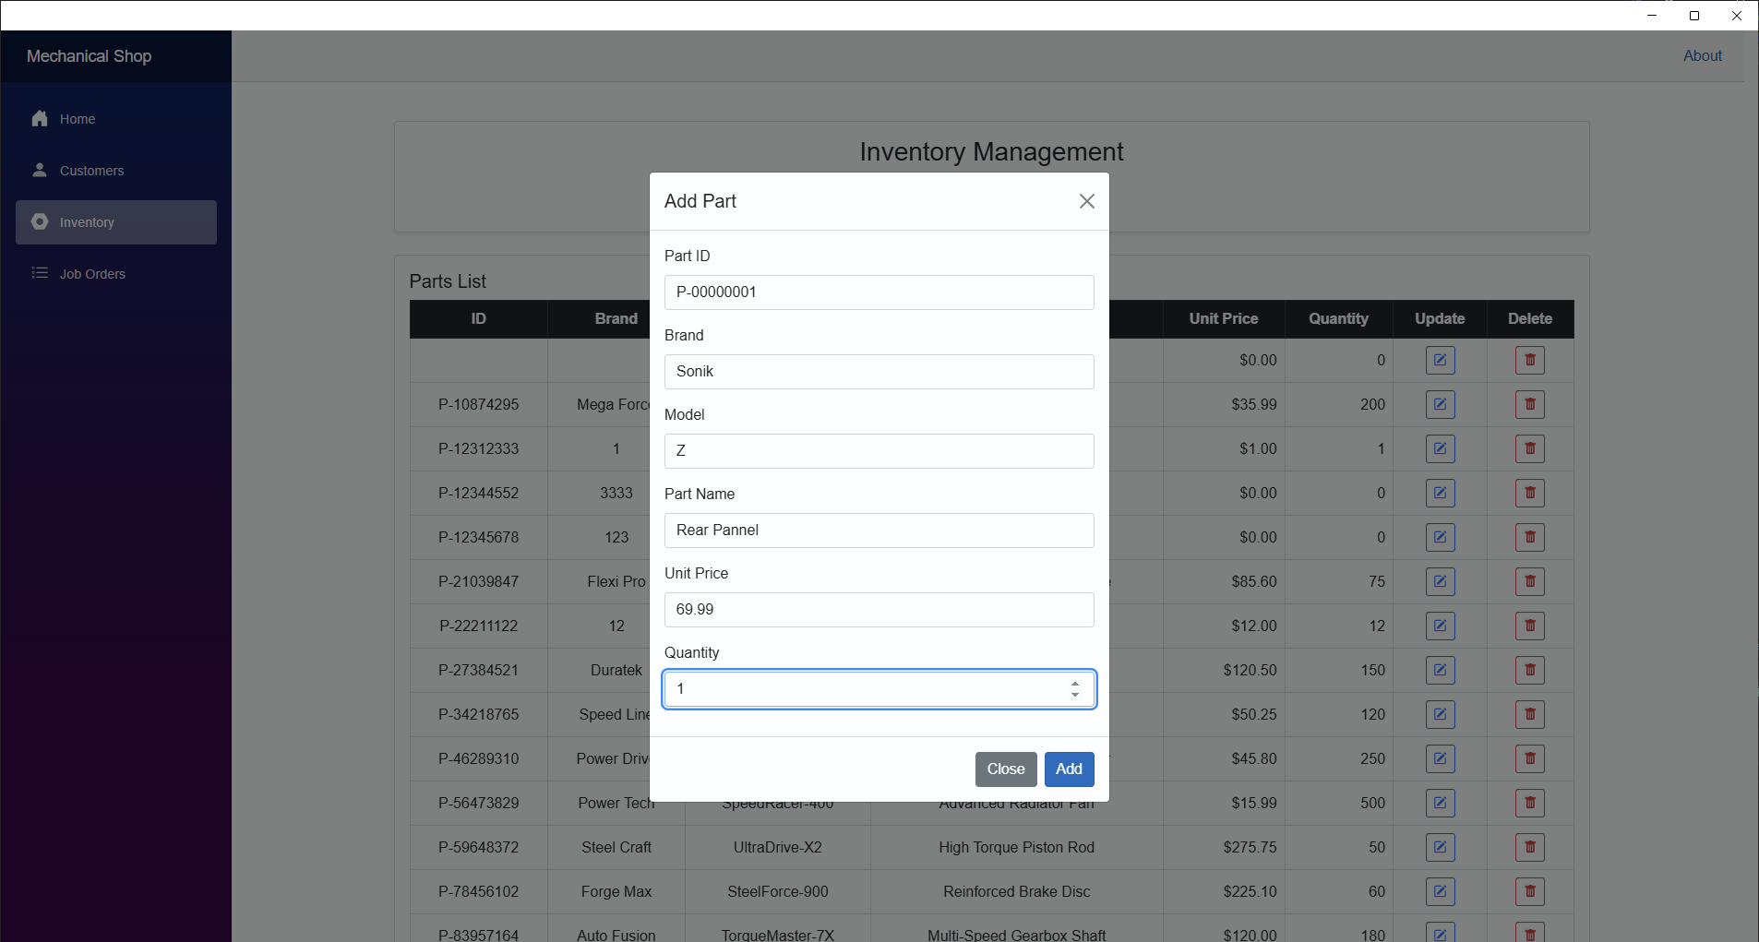

Inventory page after adding new equipment (Added equipment id P-00000001)

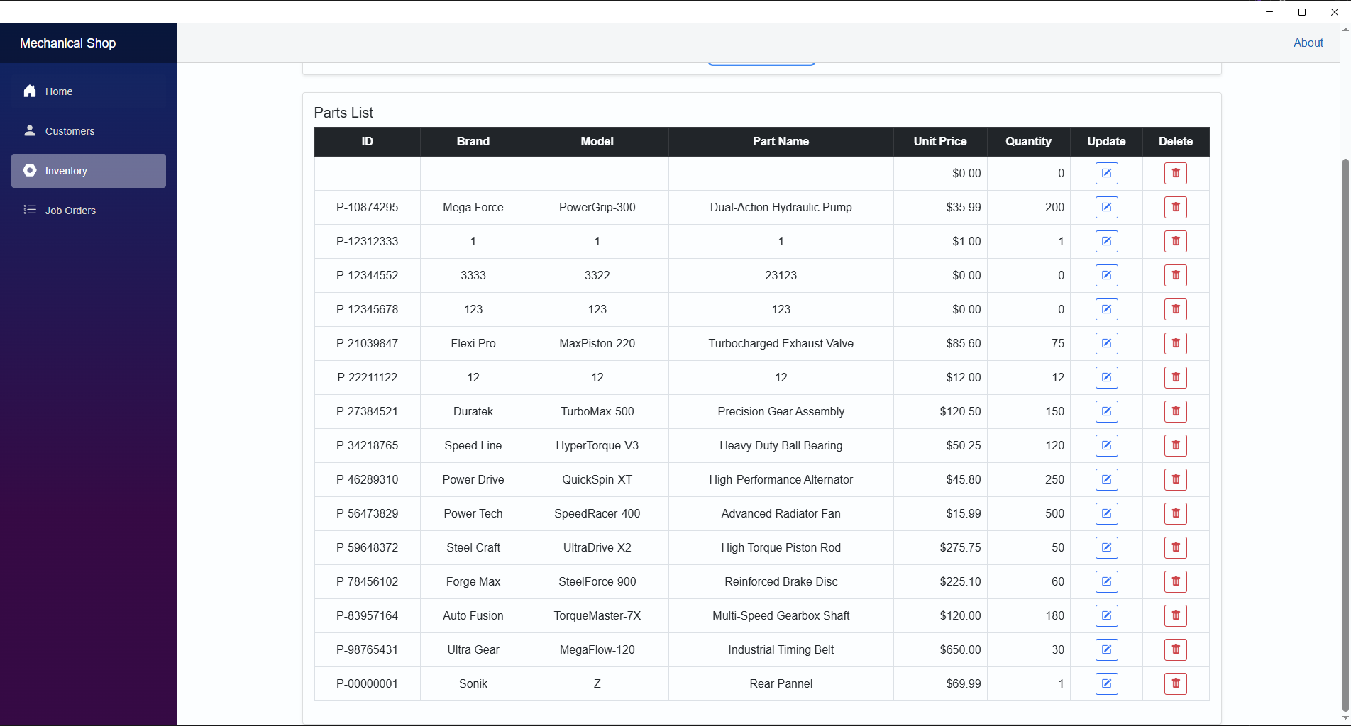

# Update Existing Equipment

Inventory page before updating existing equipment

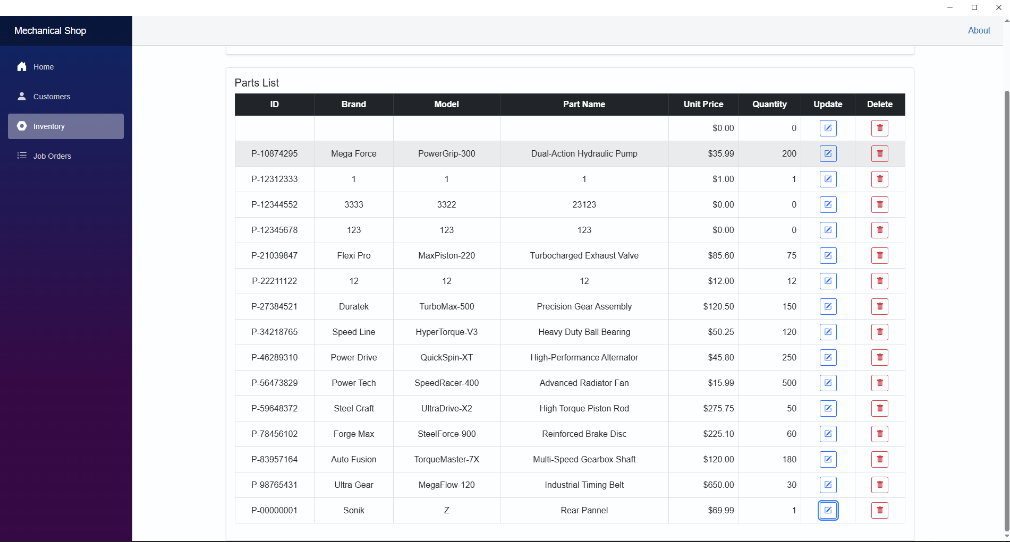

Updating existing equipment

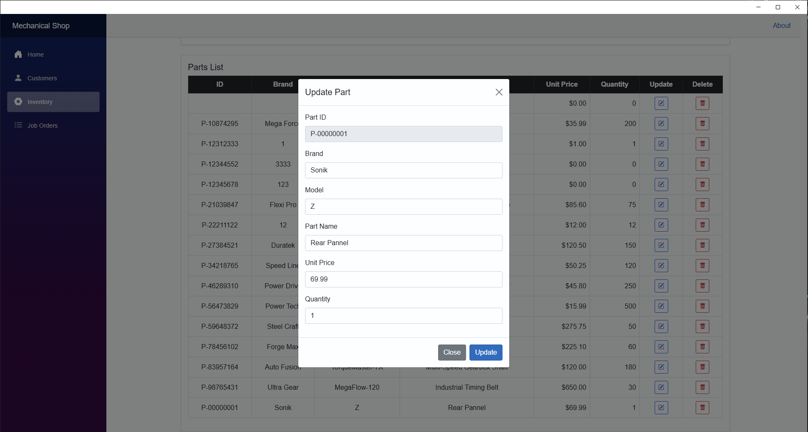

Inventory page after updating existing equipment (P-00000001 has been updated)

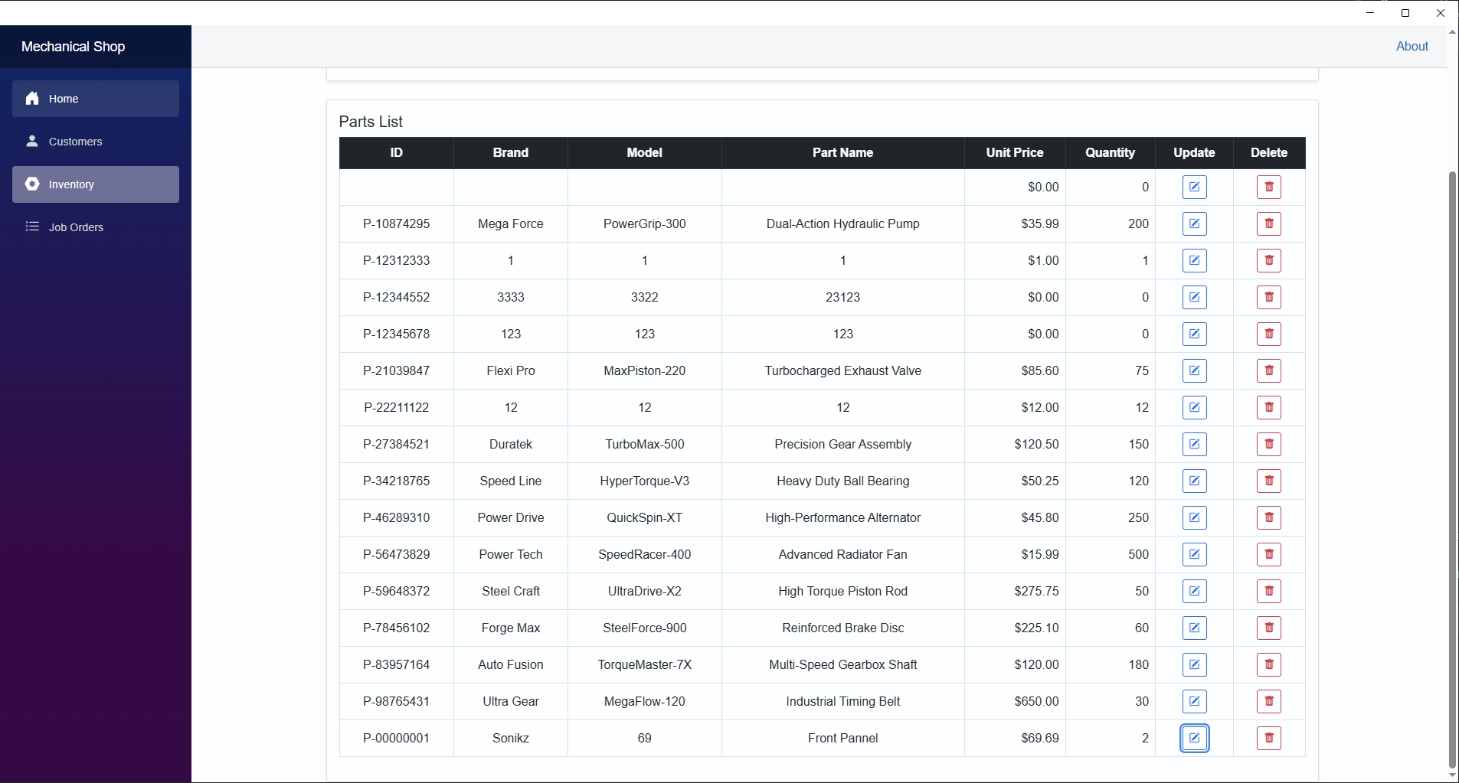

# Delete Existing Equipment

Inventory page before deleting existing equipment

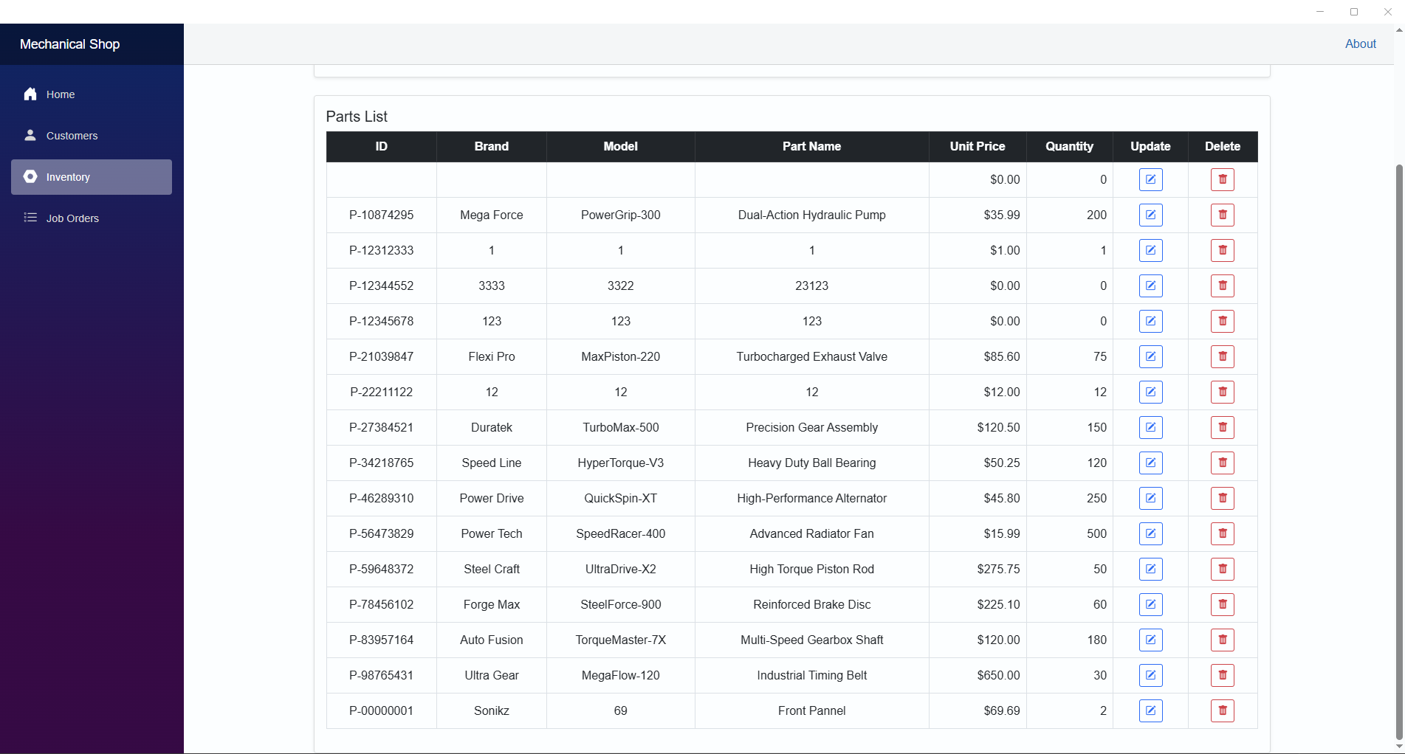

Inventory page after deleting existing equipment (P-00000001 has been deleted)

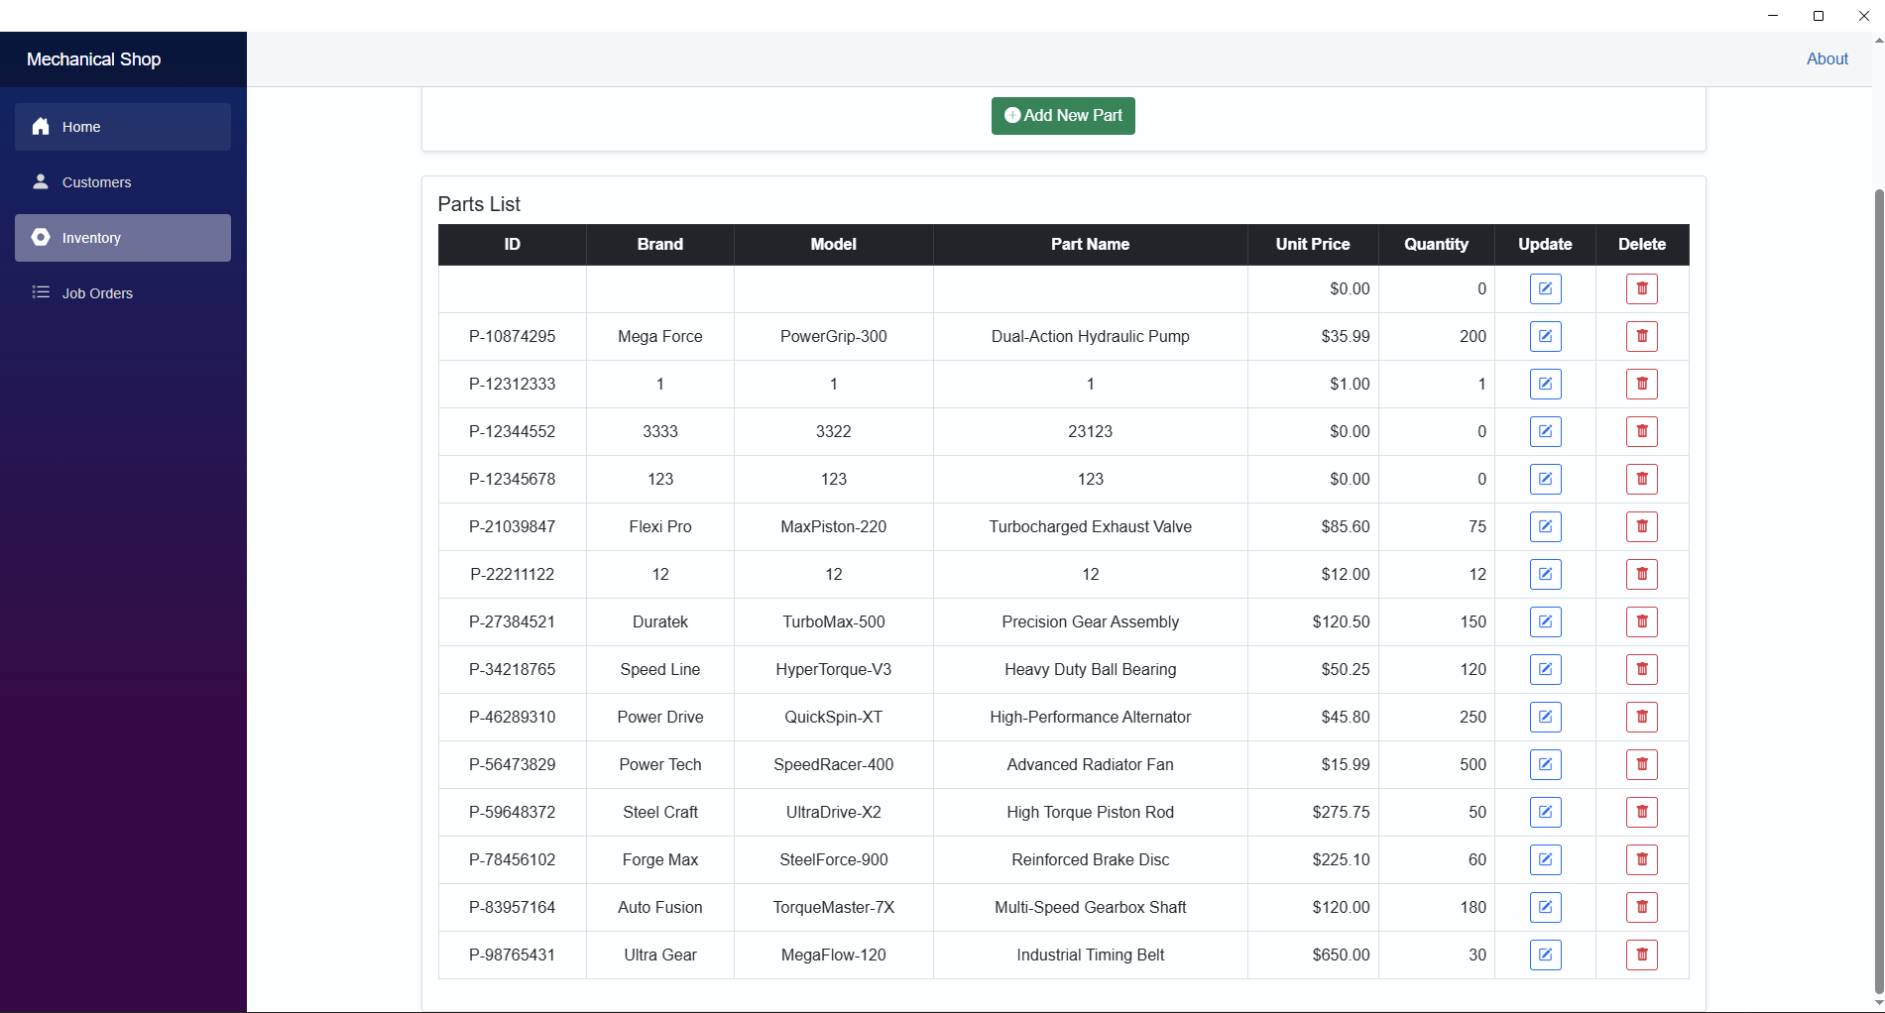

# Error Detection in Inventory Page

All fields are required to be filled out

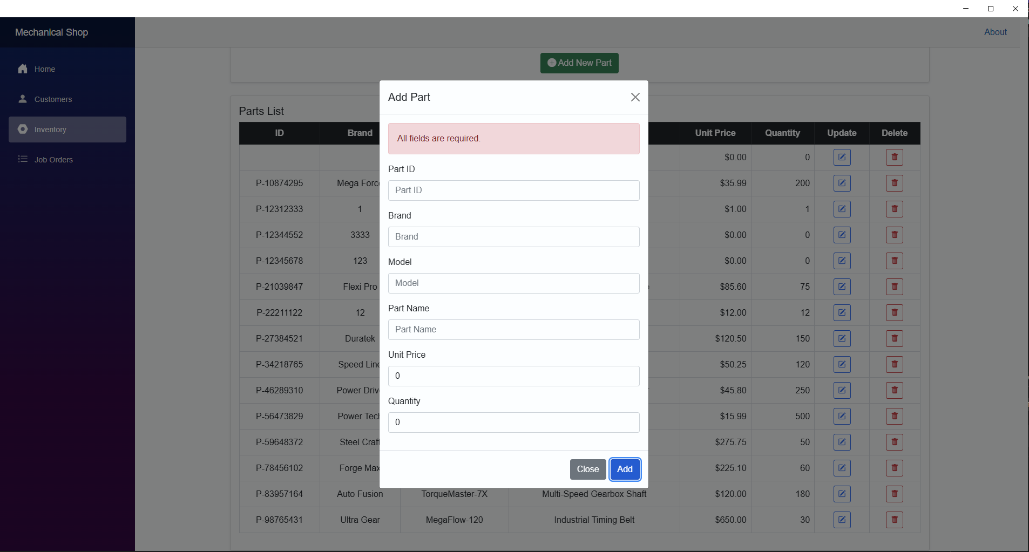

Part ID must be in format P-########

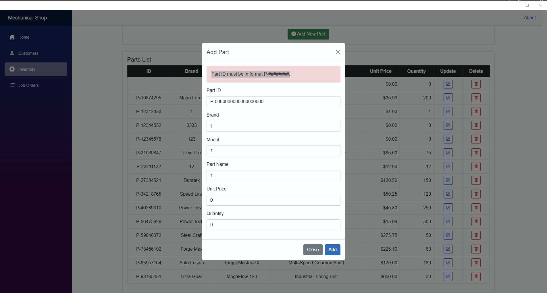

Duplicated equipment ID

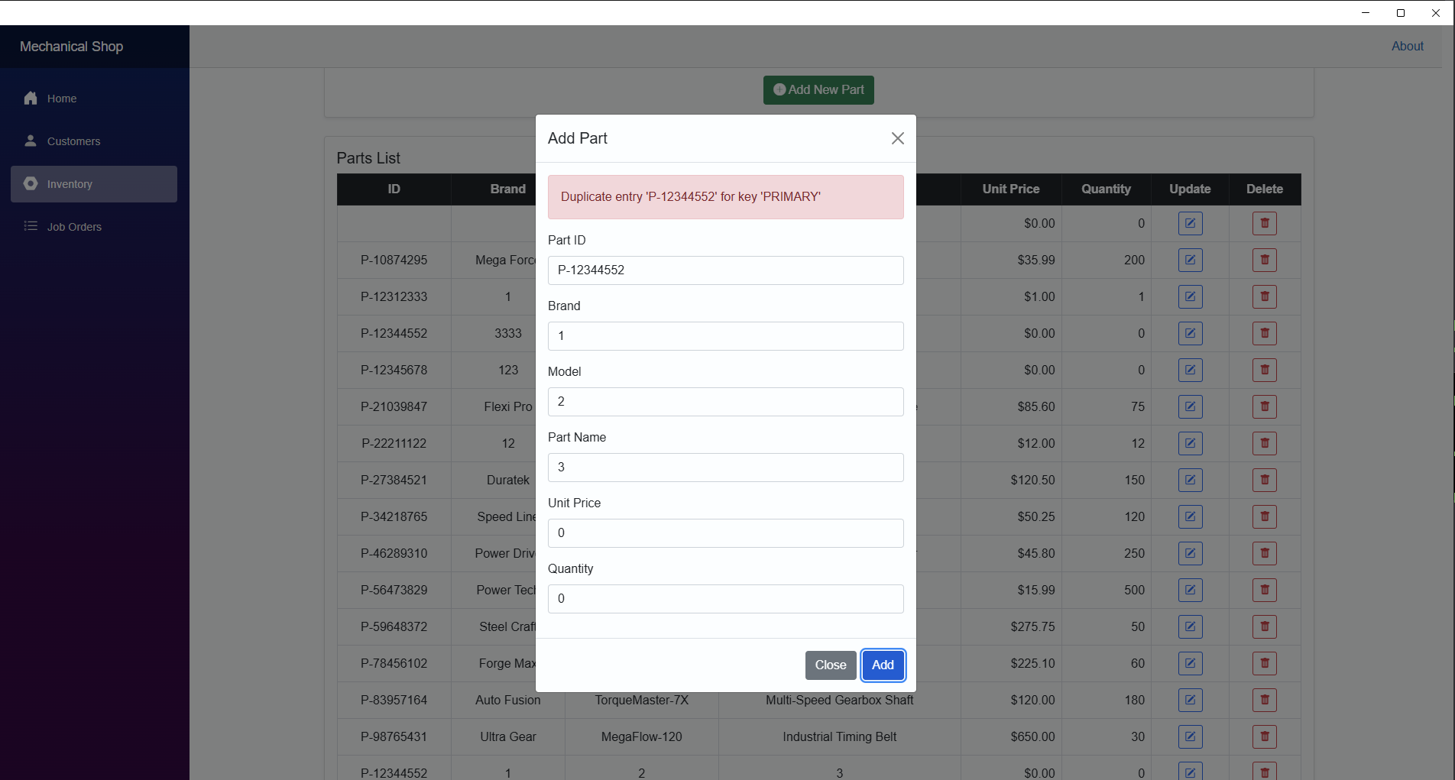

# Add a New Order

Inventory before creating a new order.

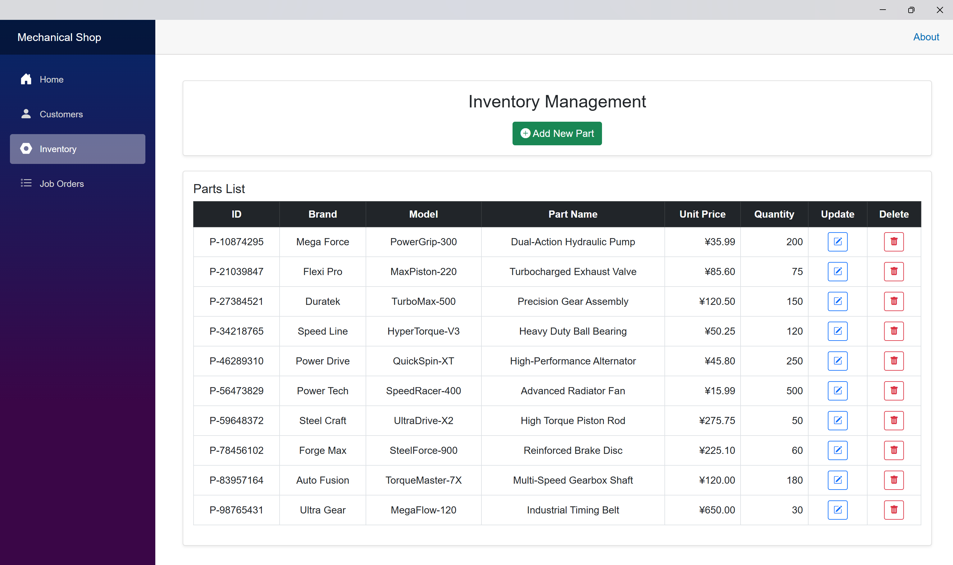

Create a new order.

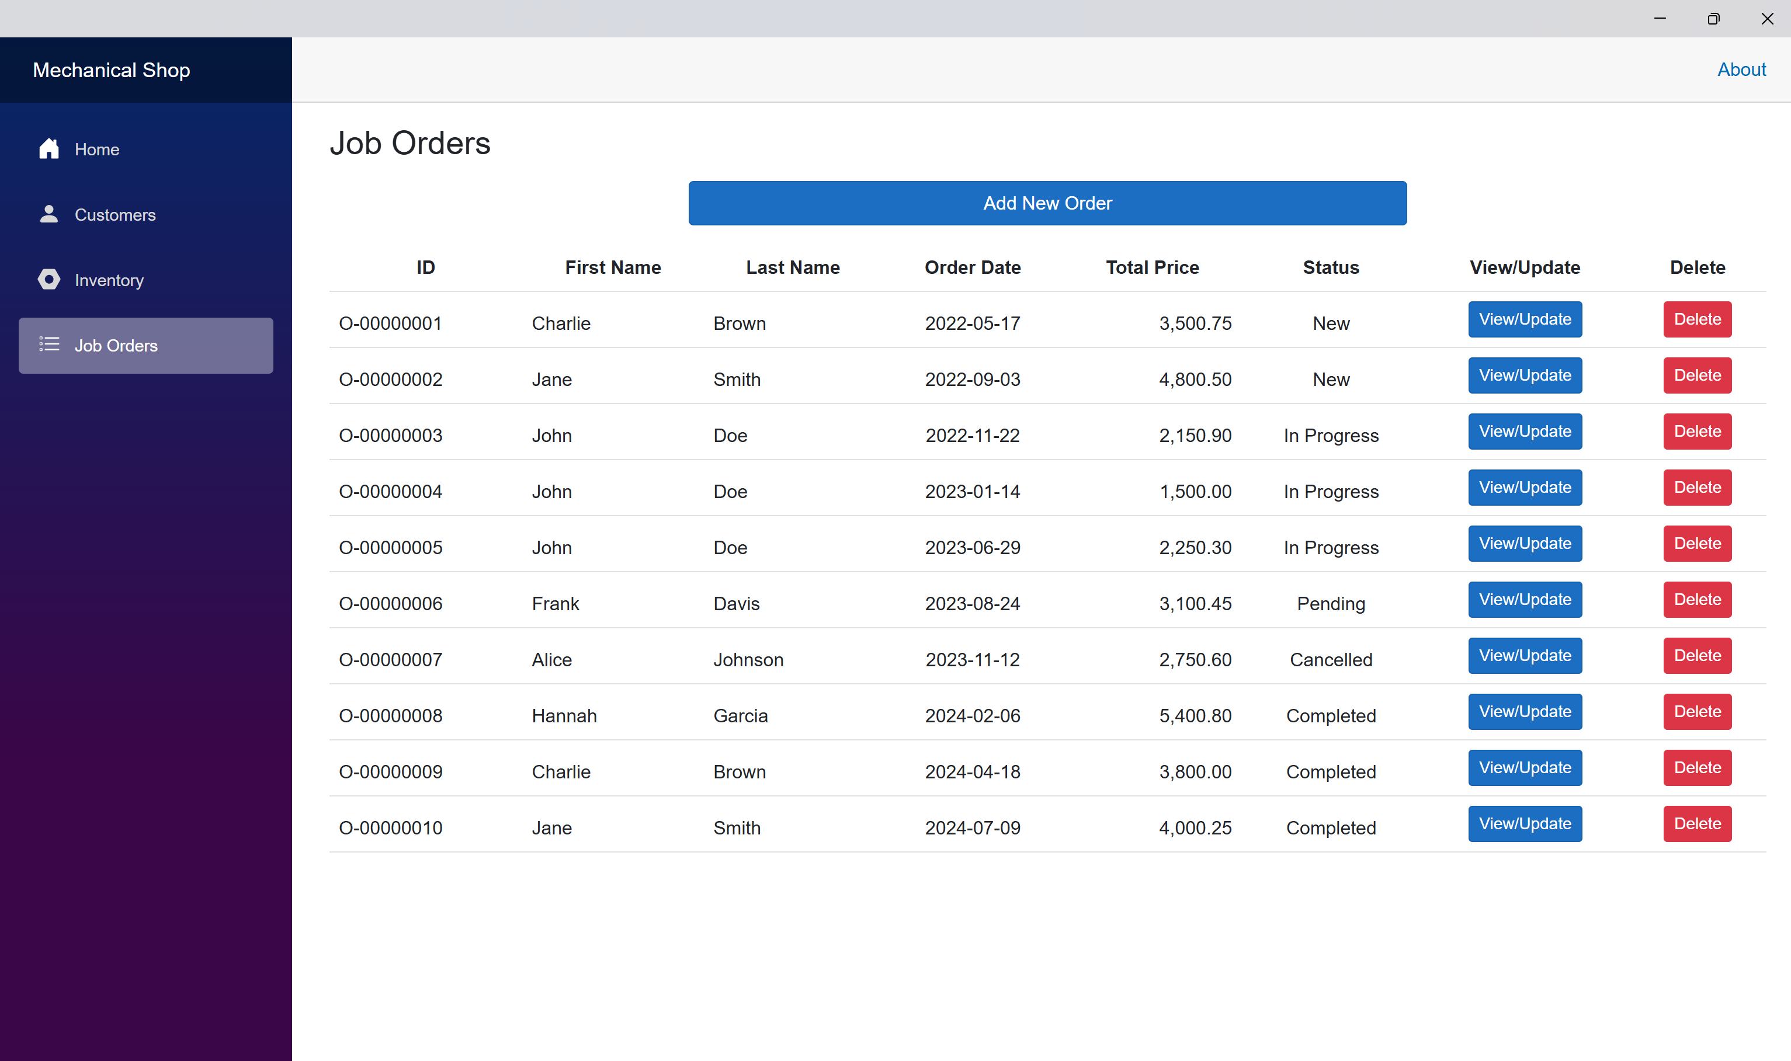

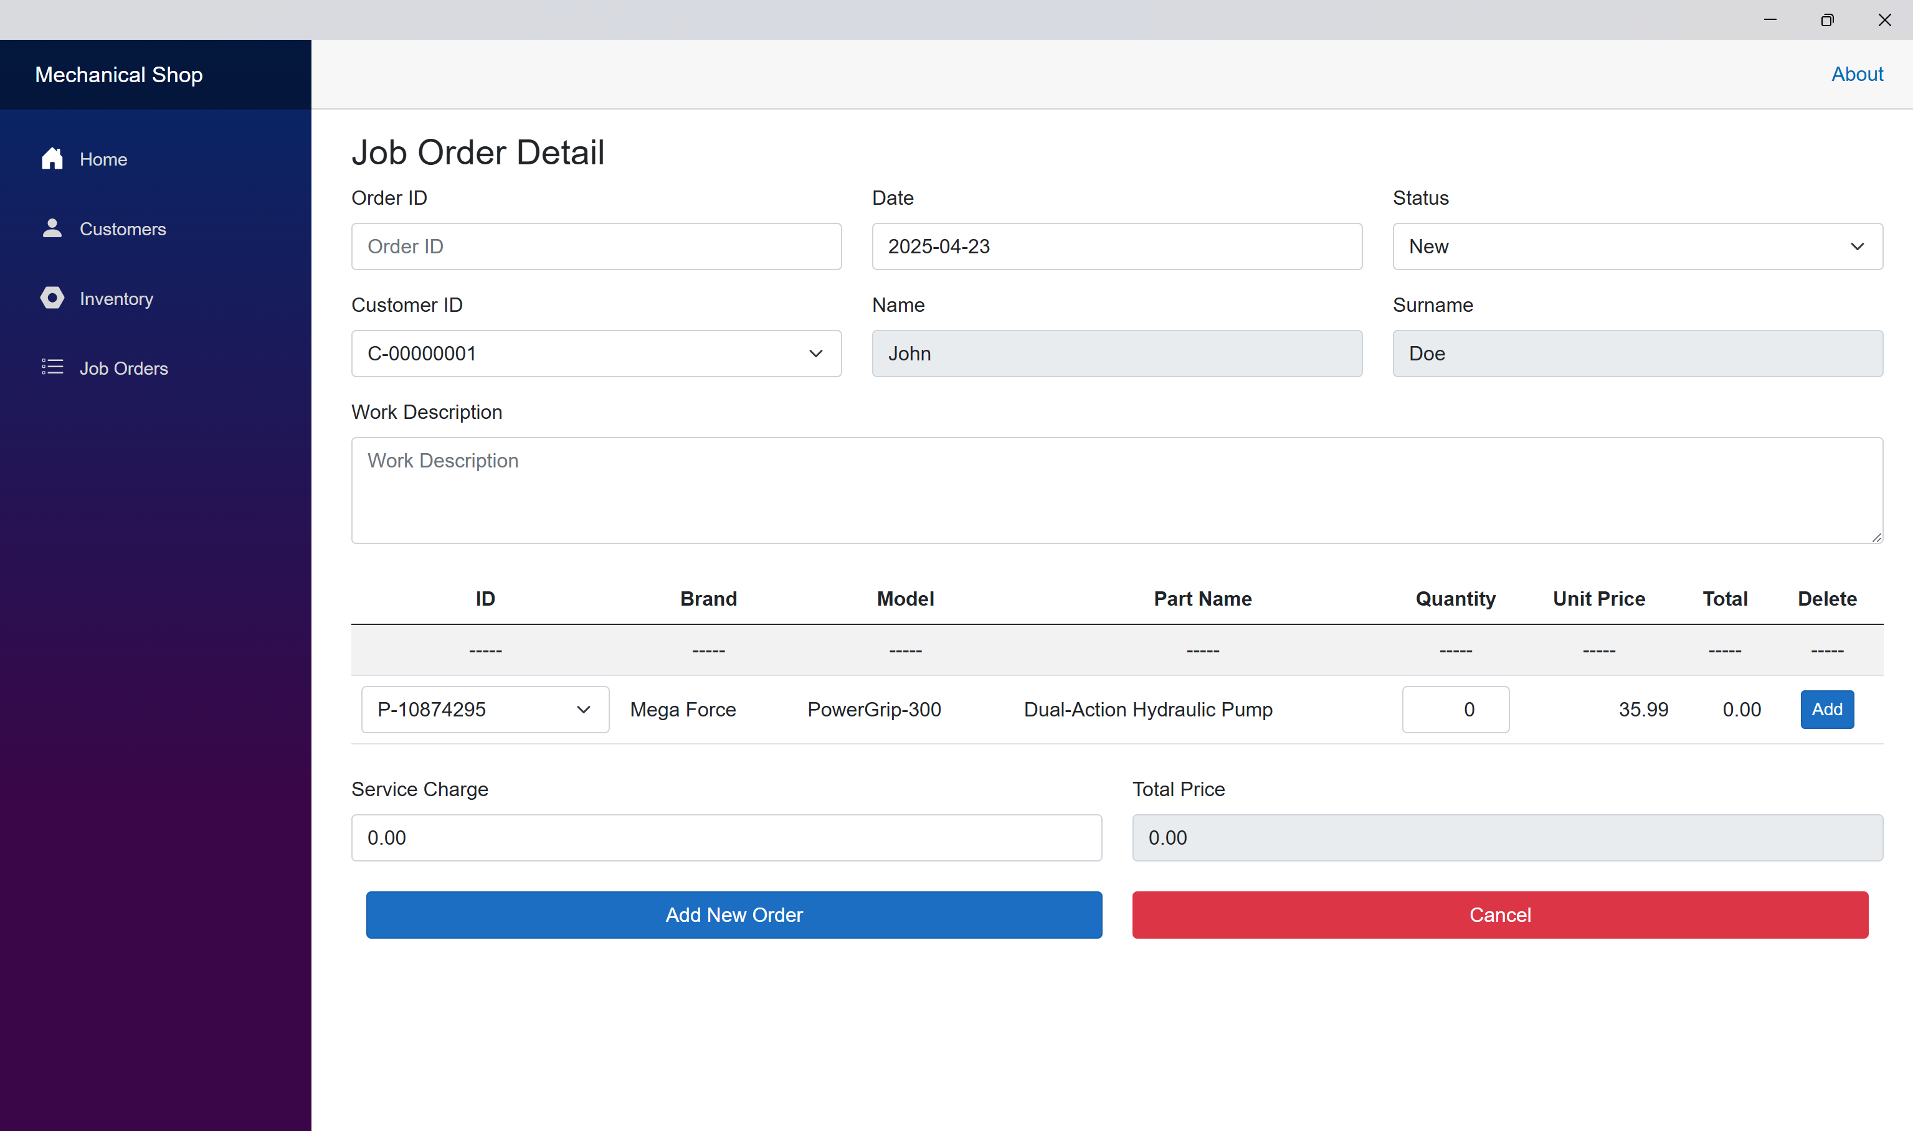

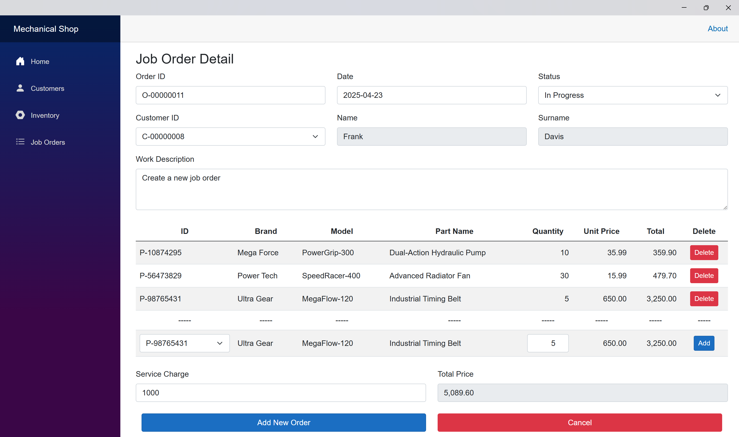

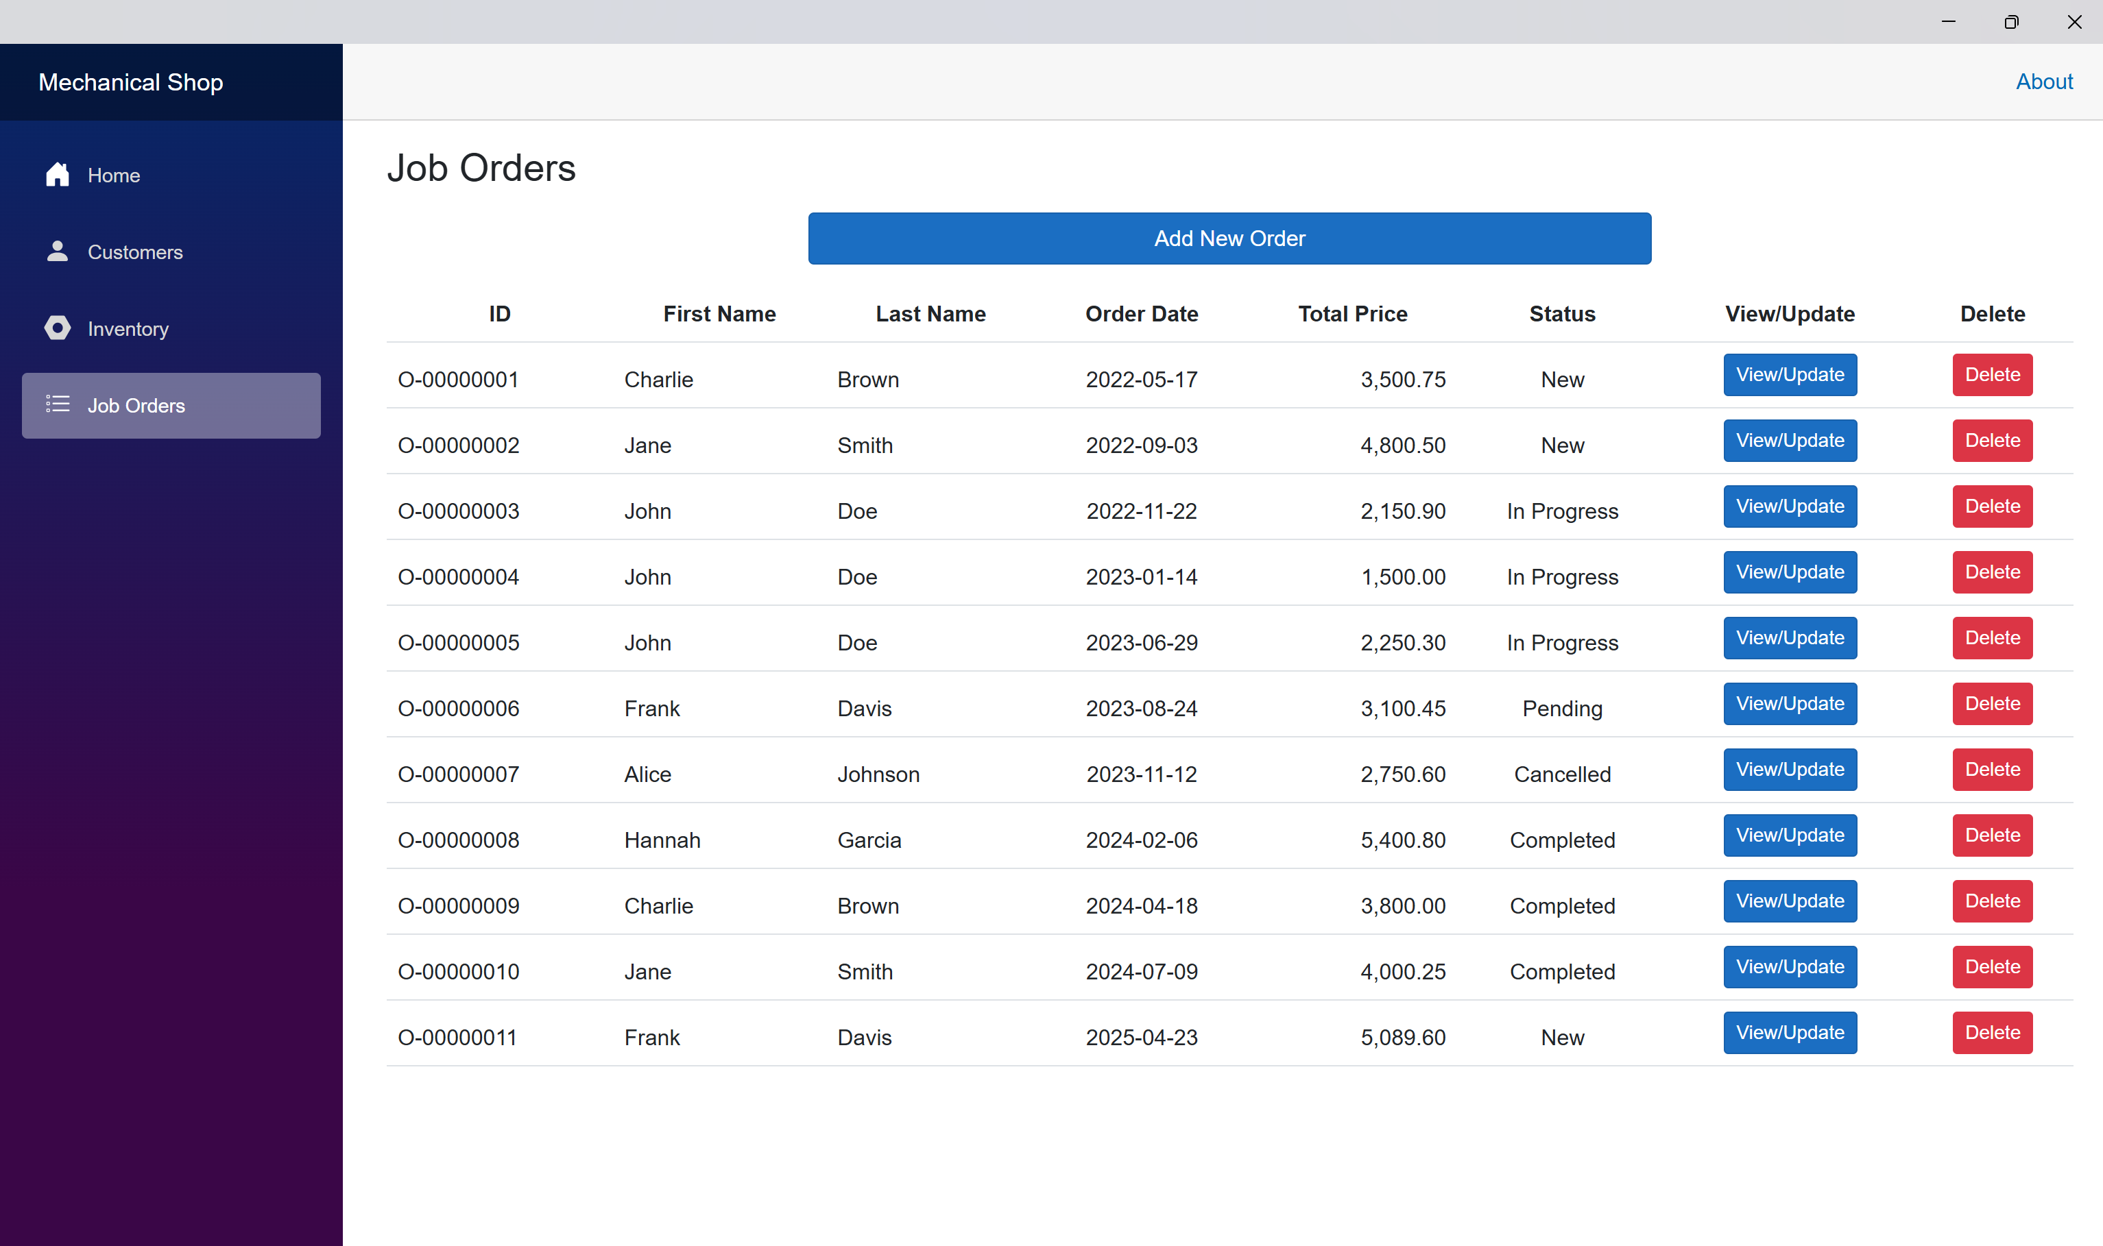

Inventory after creating a new order.

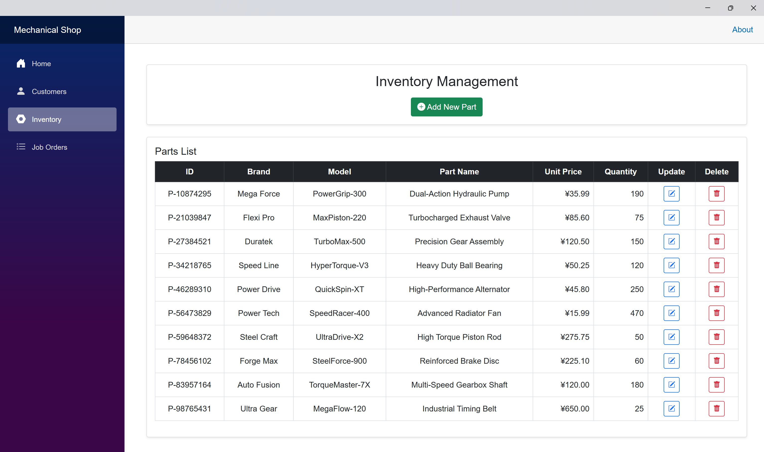

# Update an Existing Order

Inventory before updating an existing order.



Update an existing order.

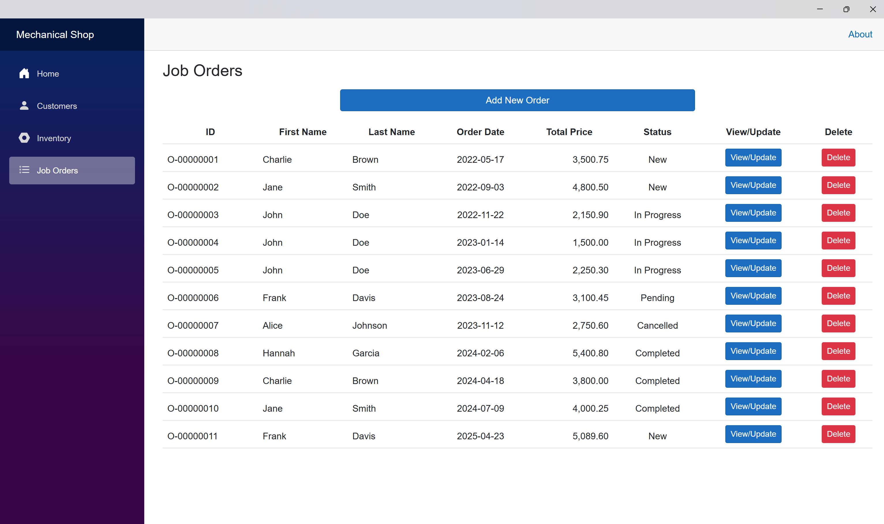

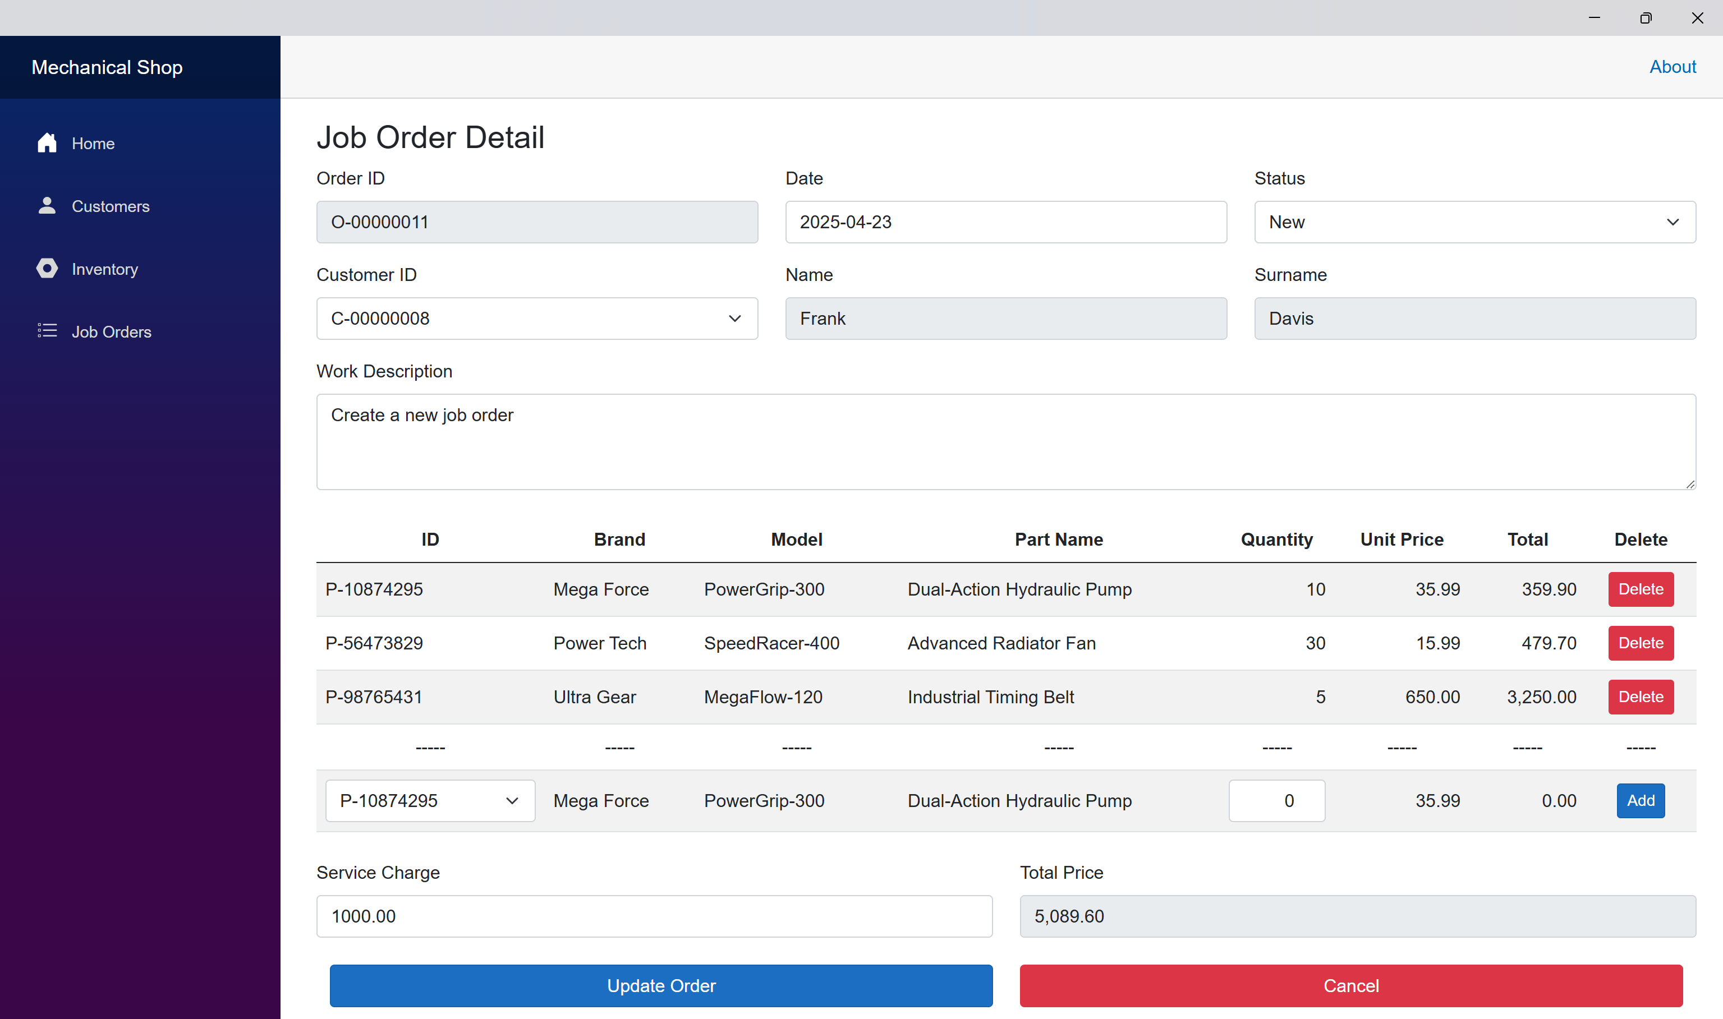

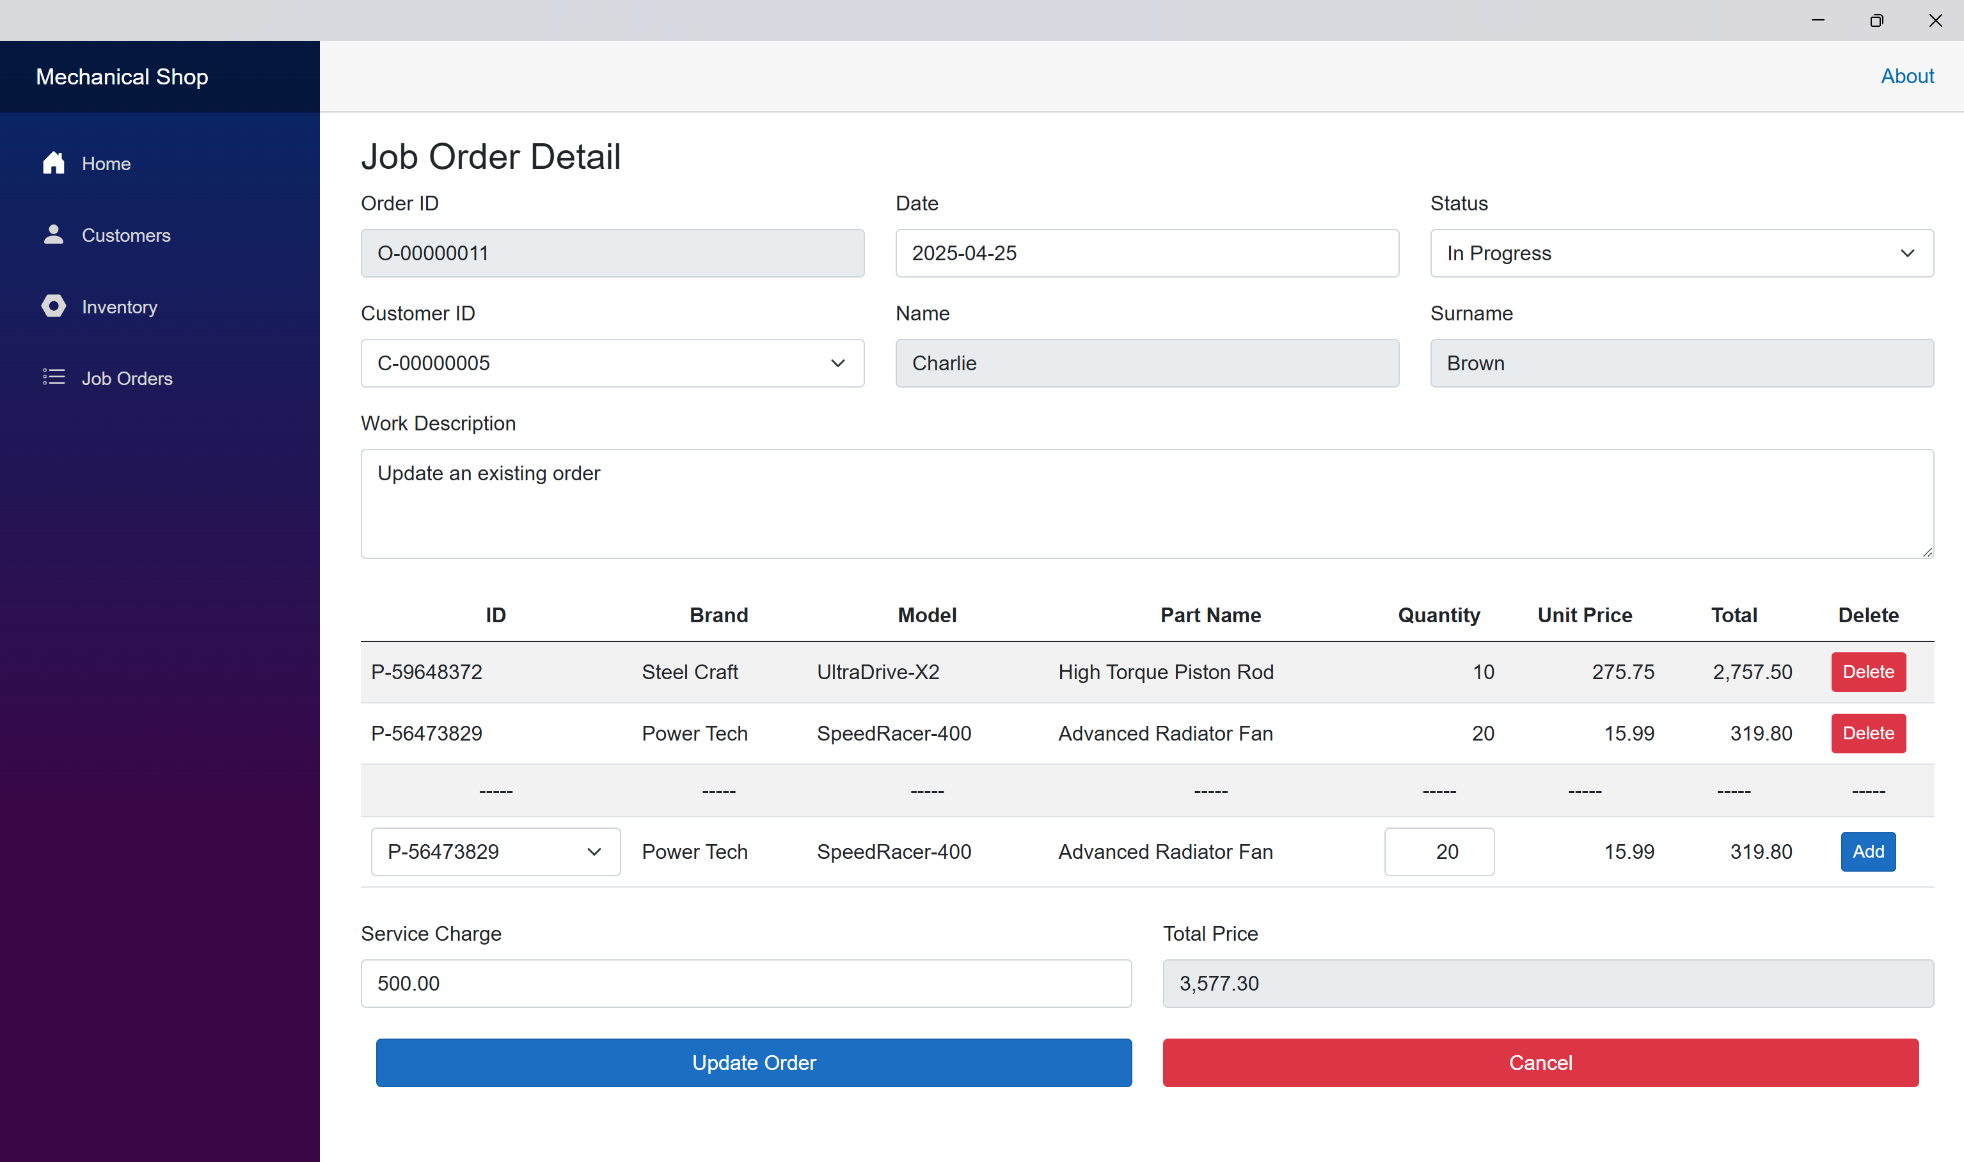

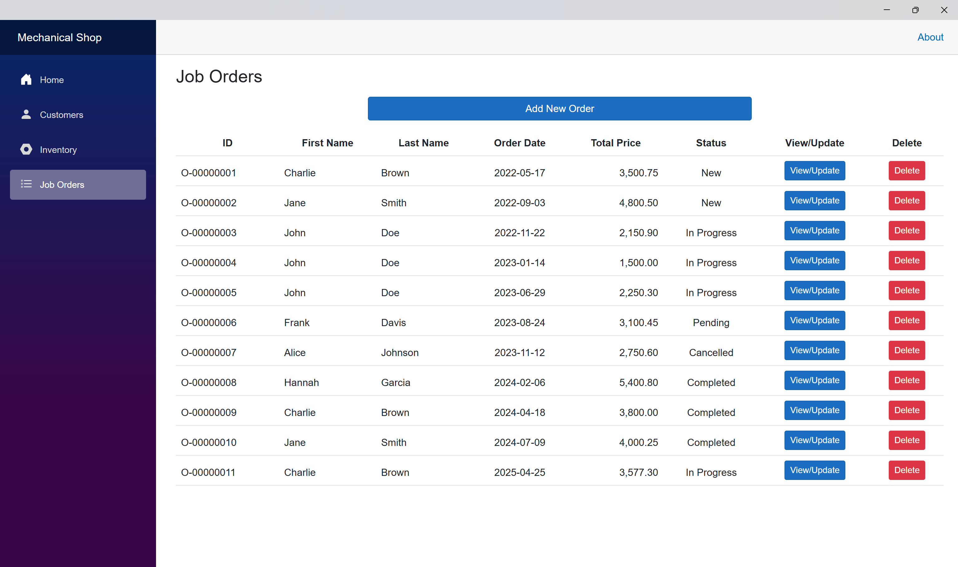

Inventory after updating an existing order.

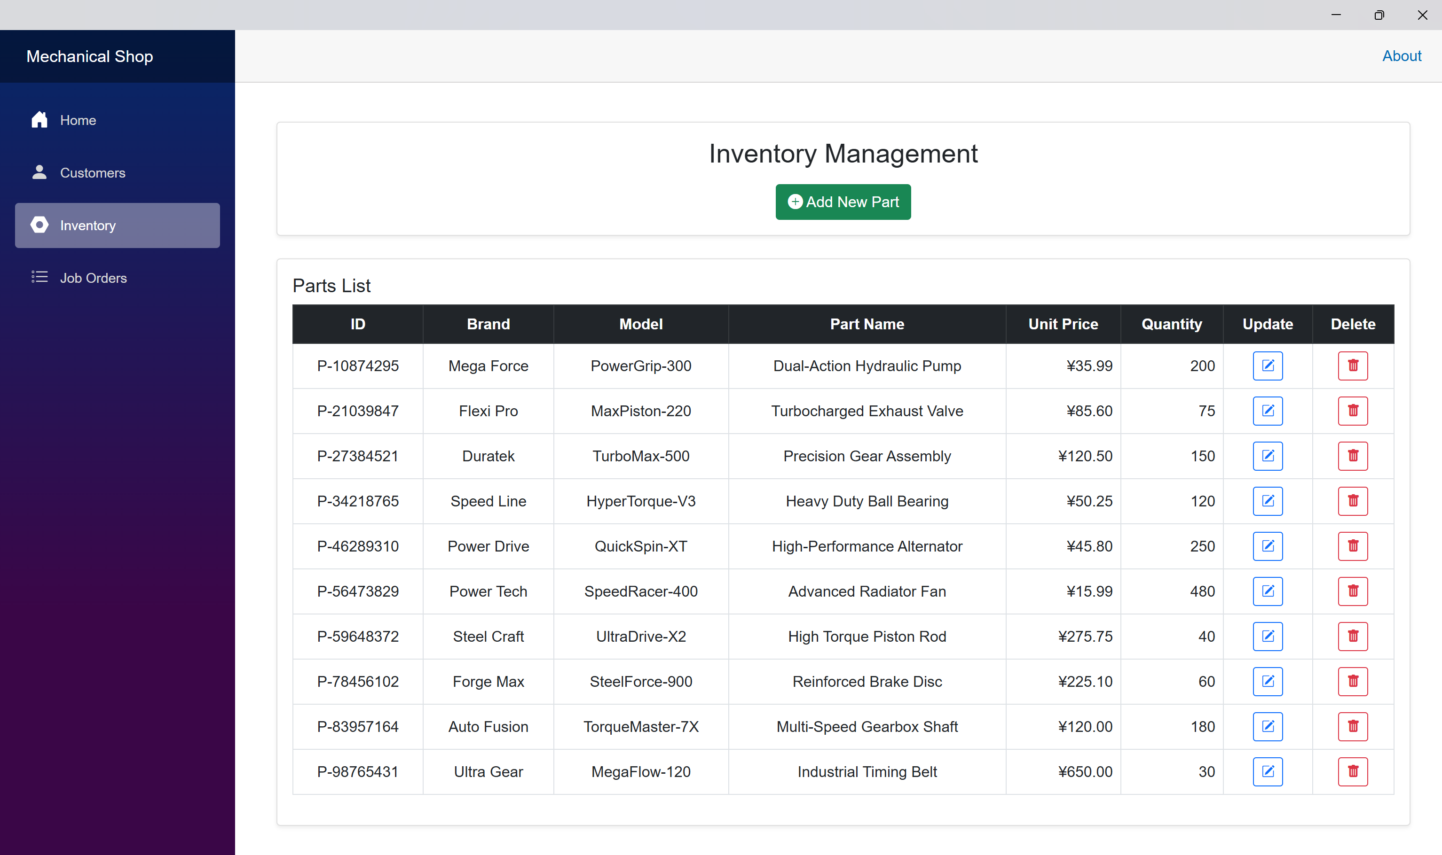

# Delete an Existing Order

Inventory before deleting an existing order.



Delete an existing order



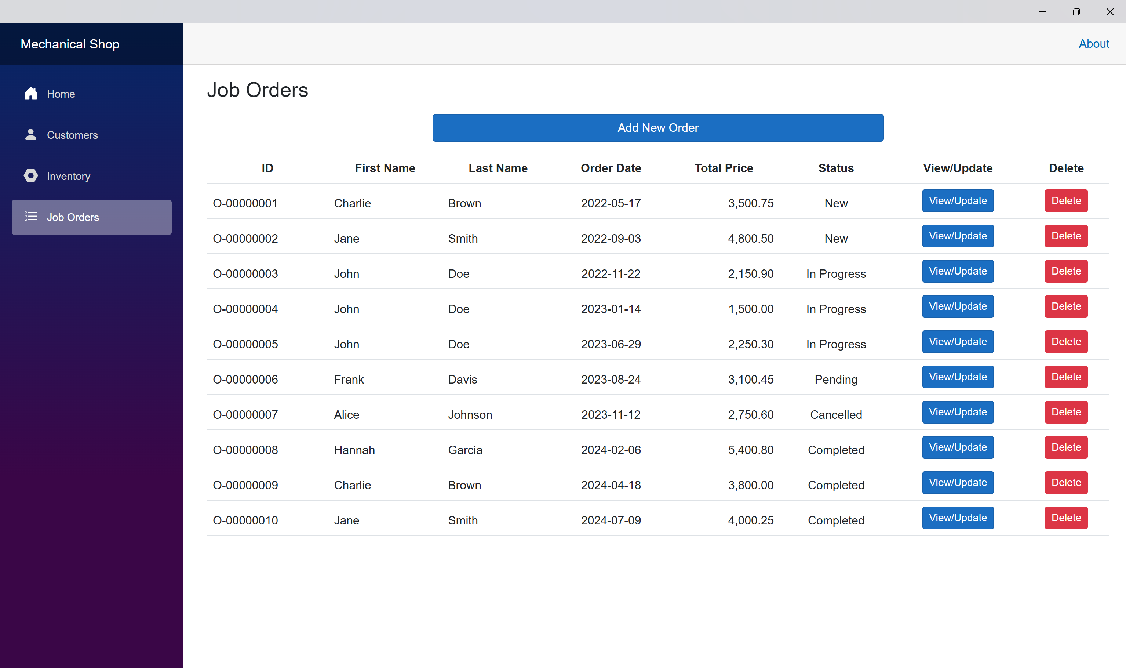

Inventory after deleting an existing order.

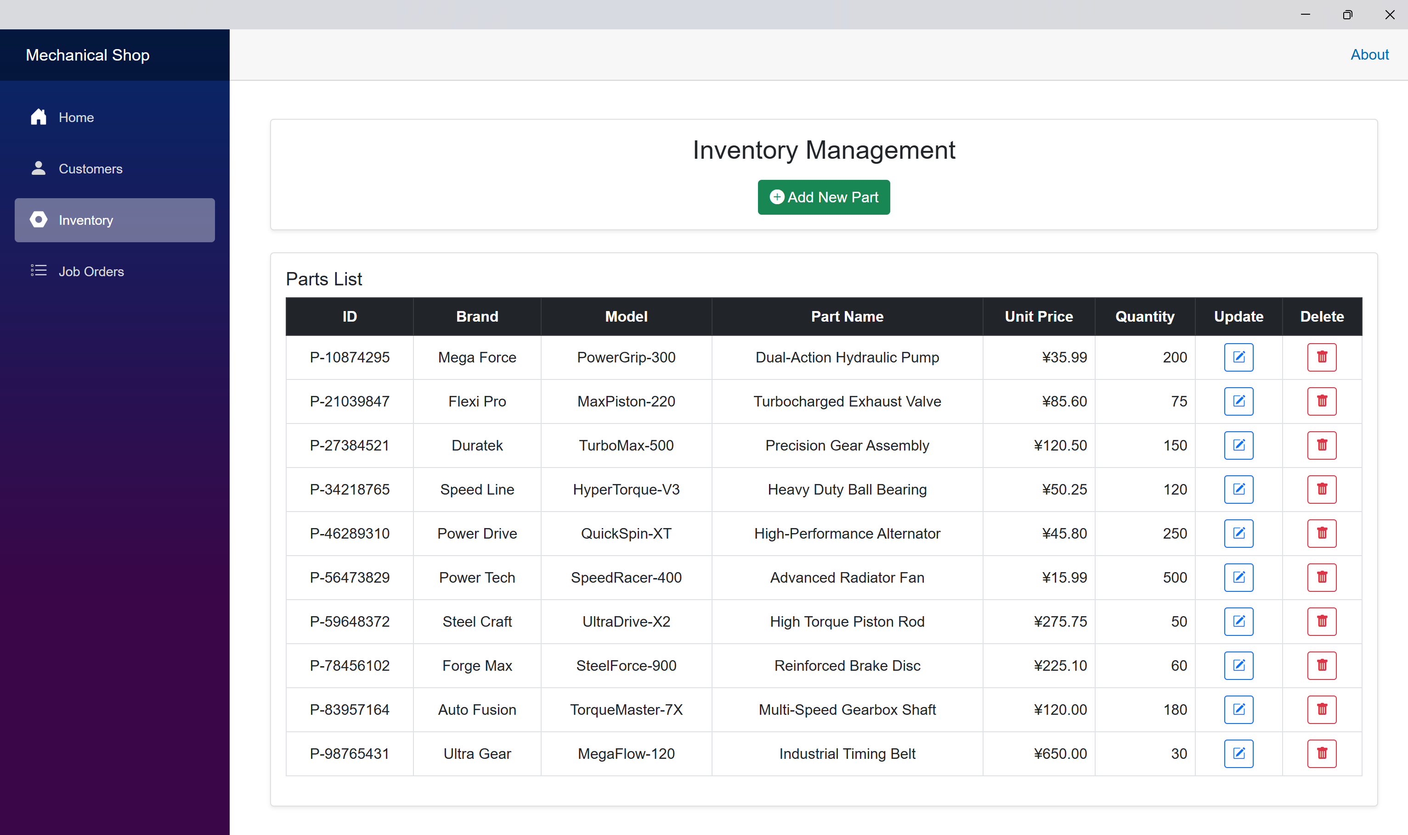

# Error Detections

## Wrong job order ID format

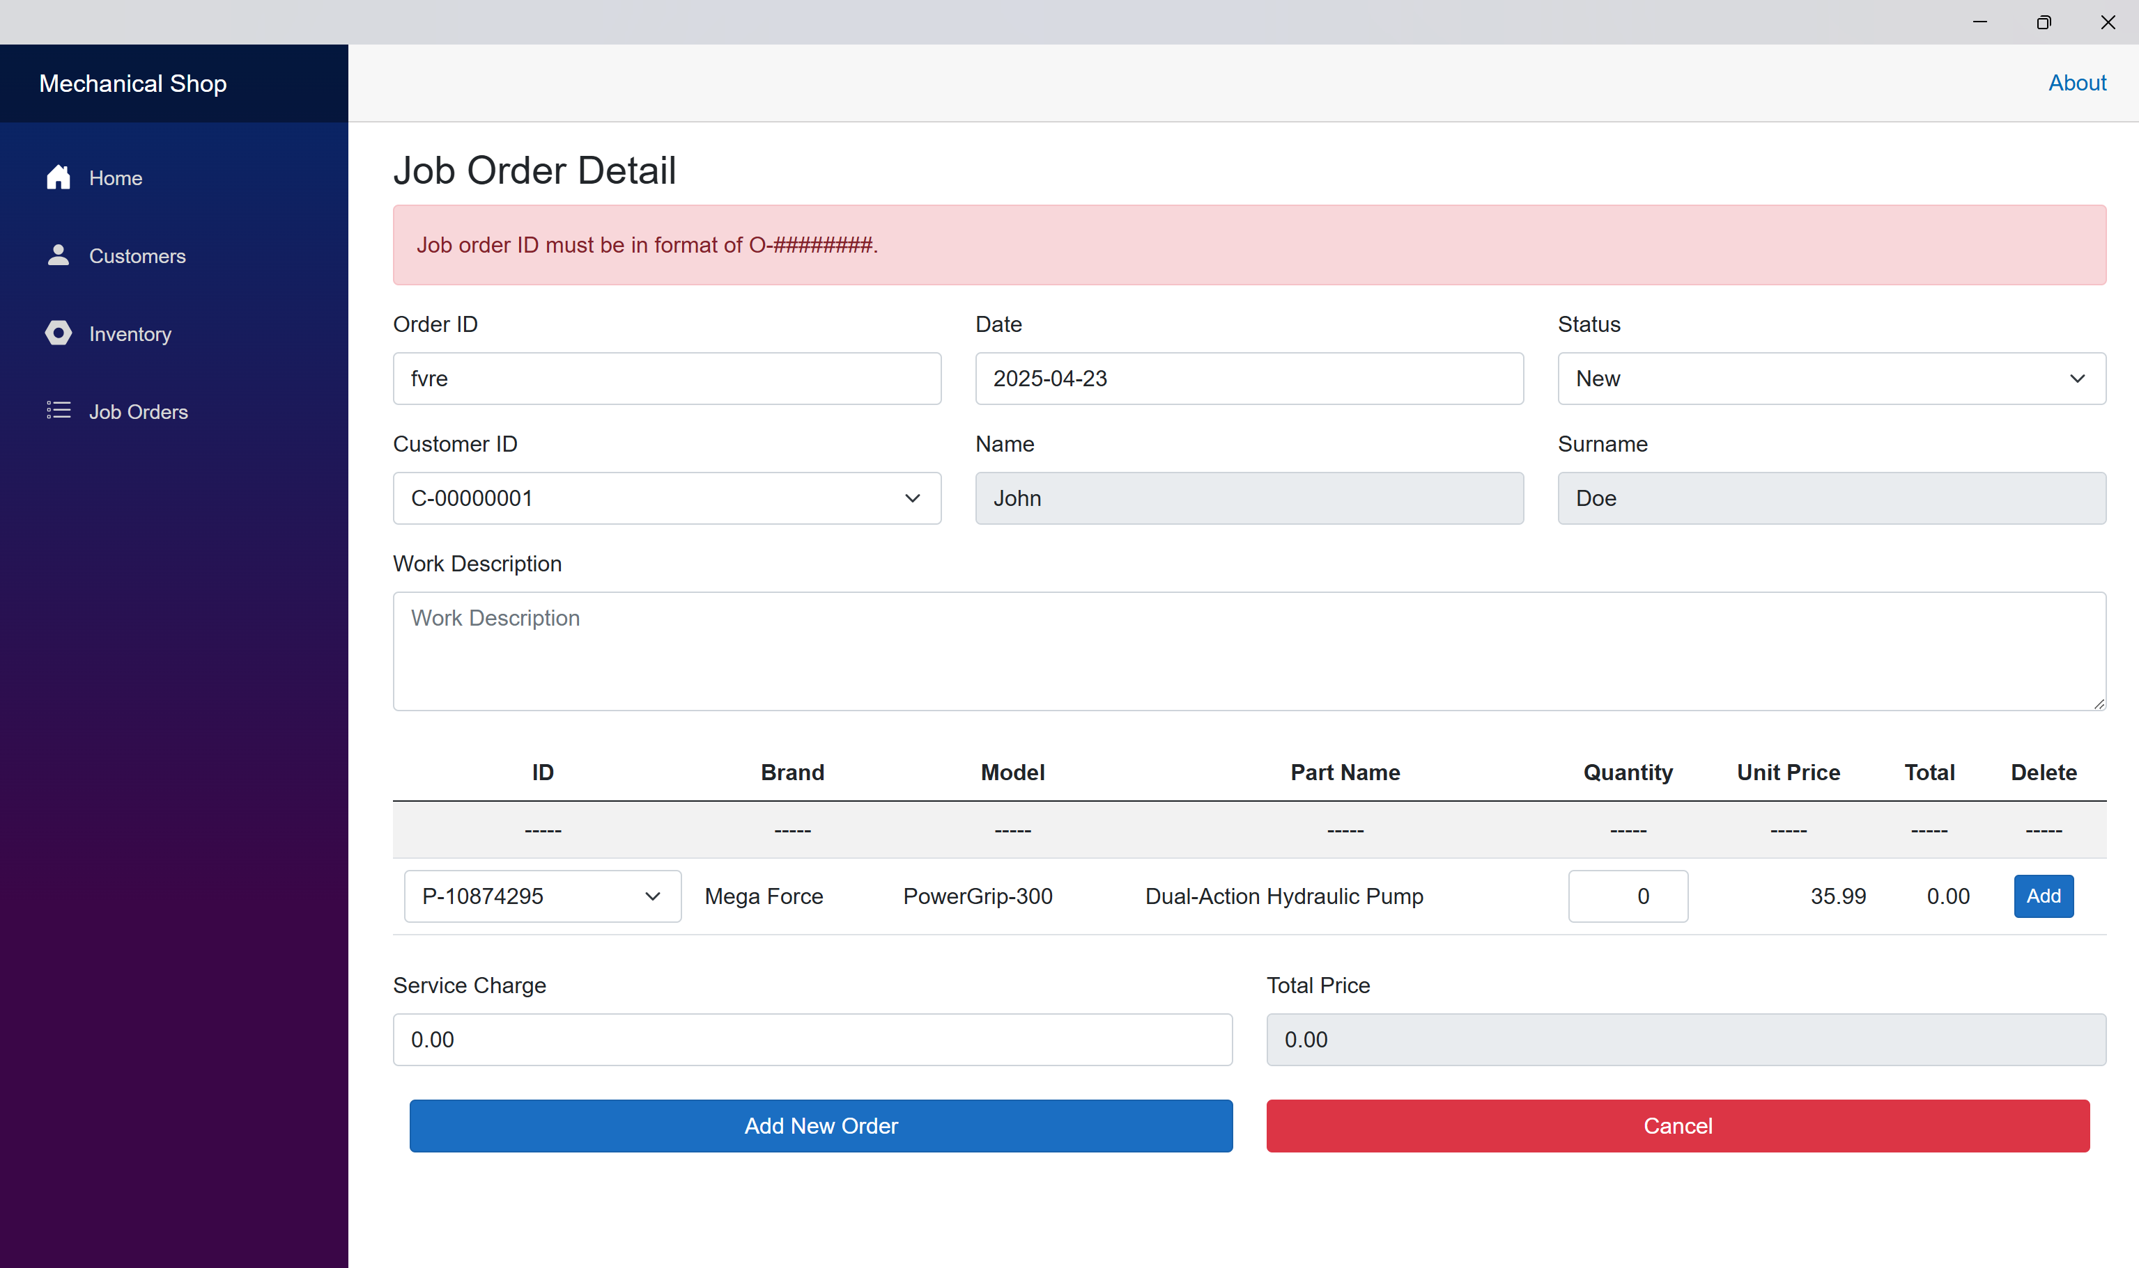

## Wrong date format

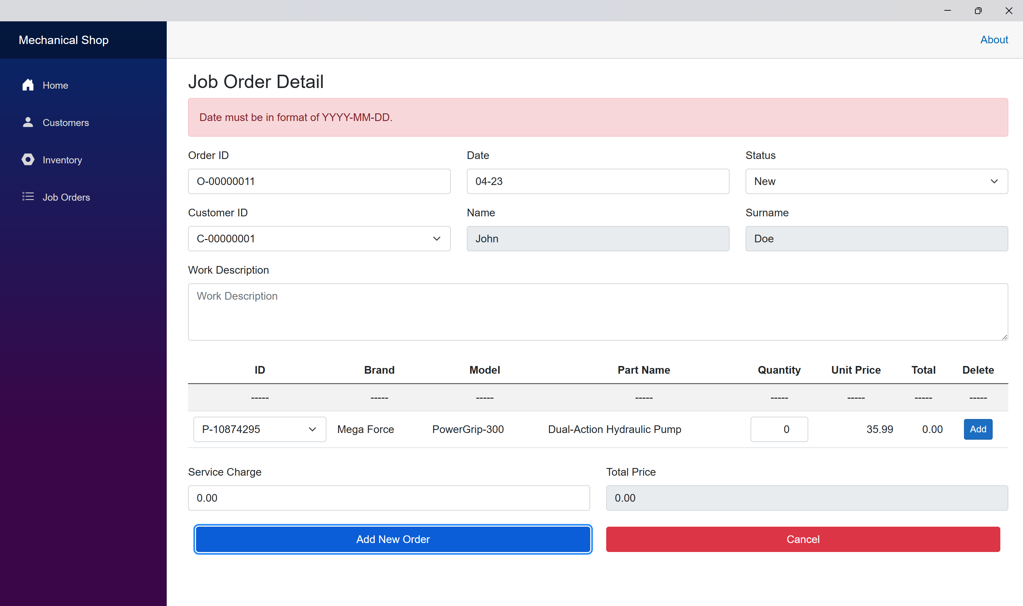

## Blank work description

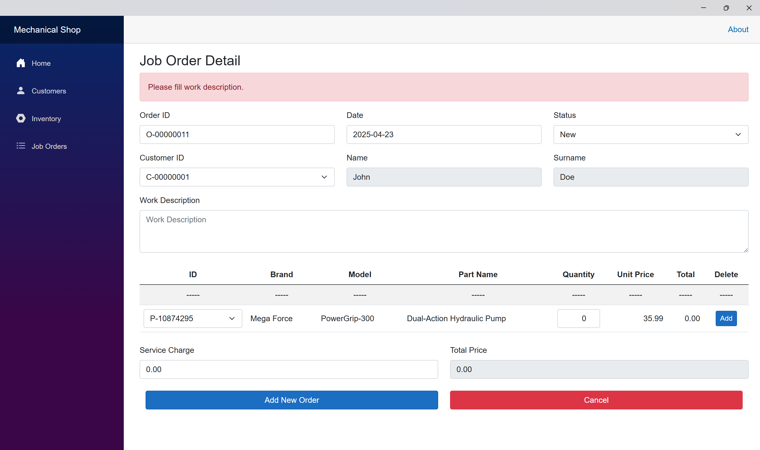

## No item in job order

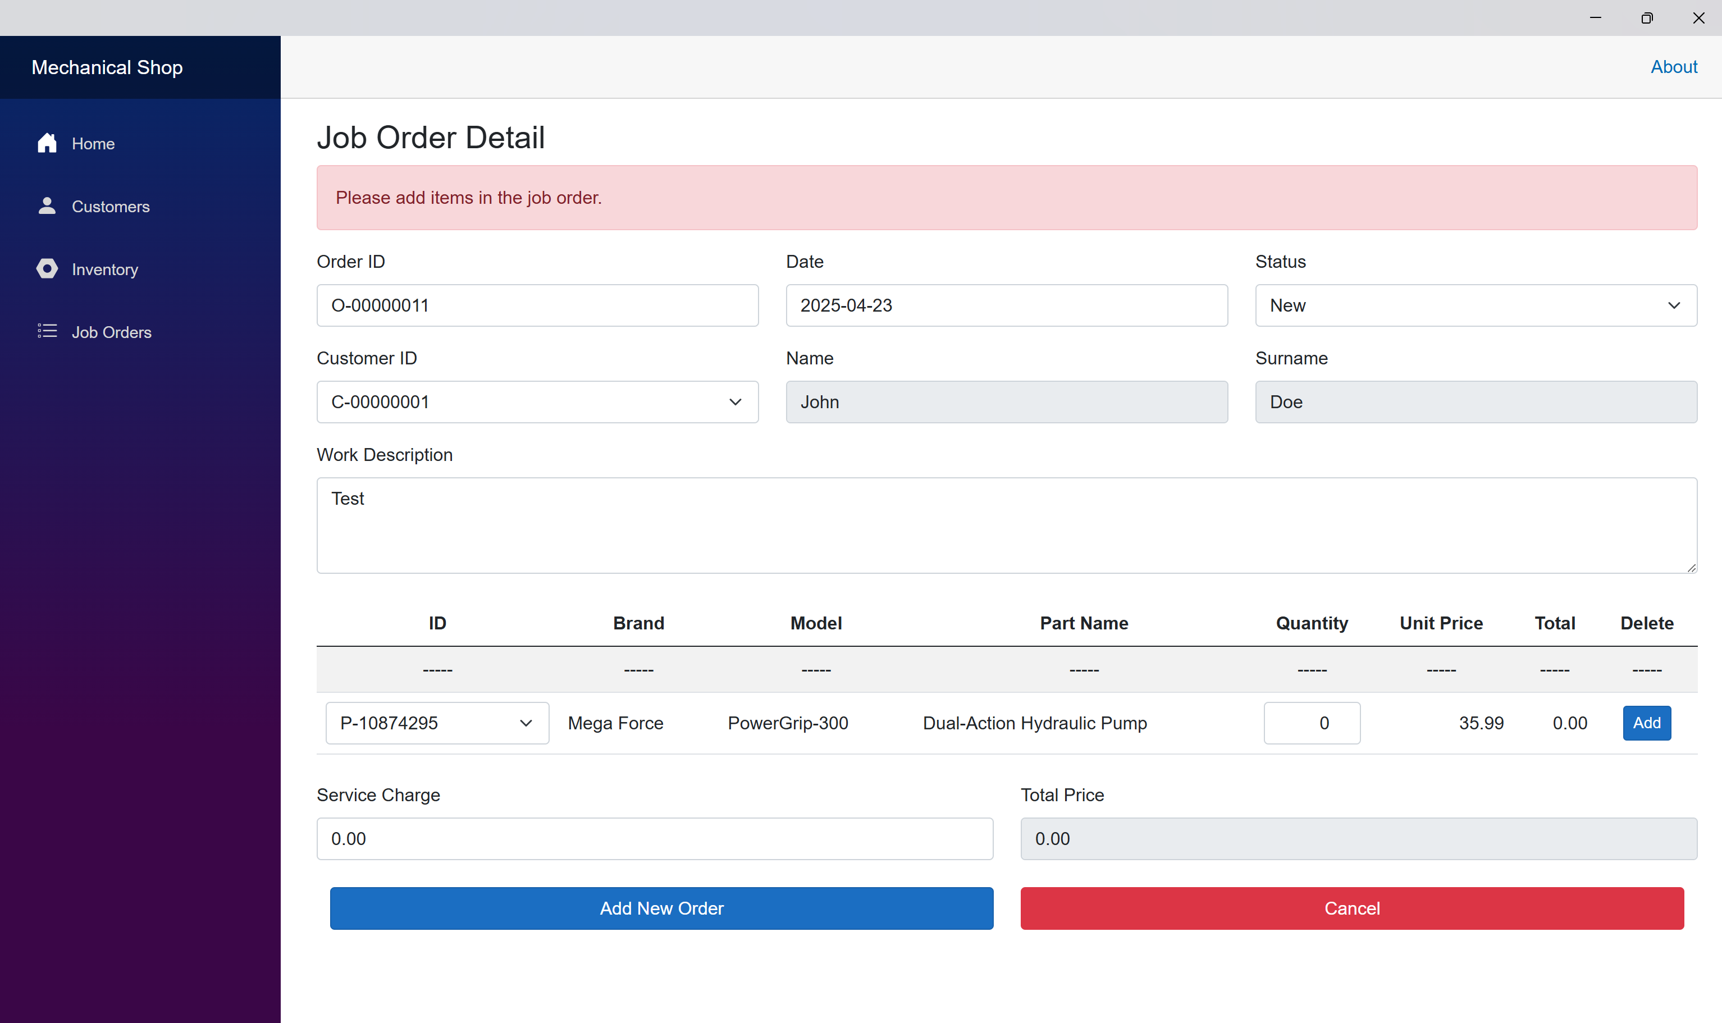

## Quantity is less than 1

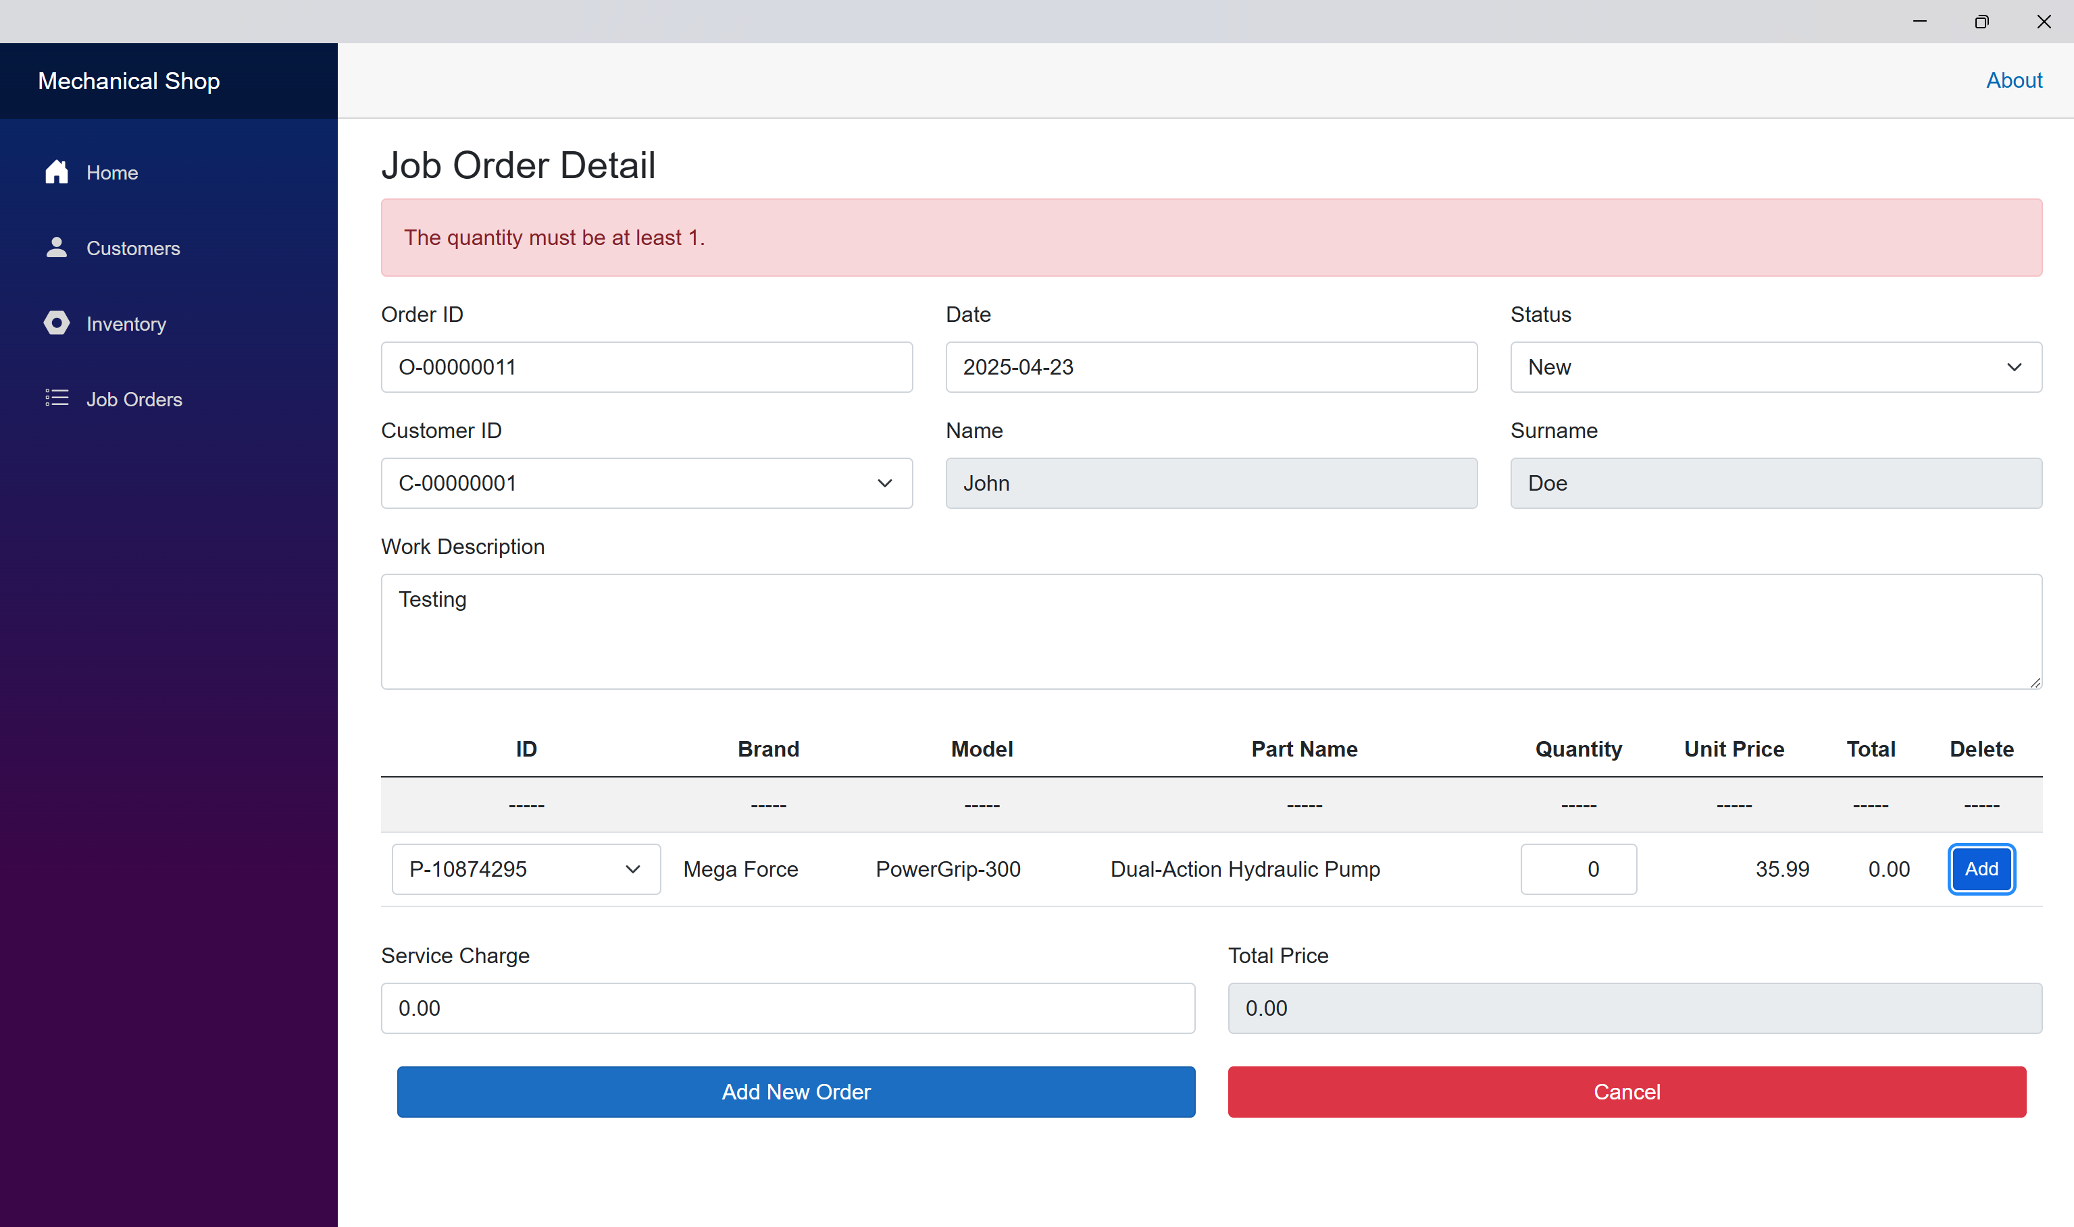

## Quantity is not a number.

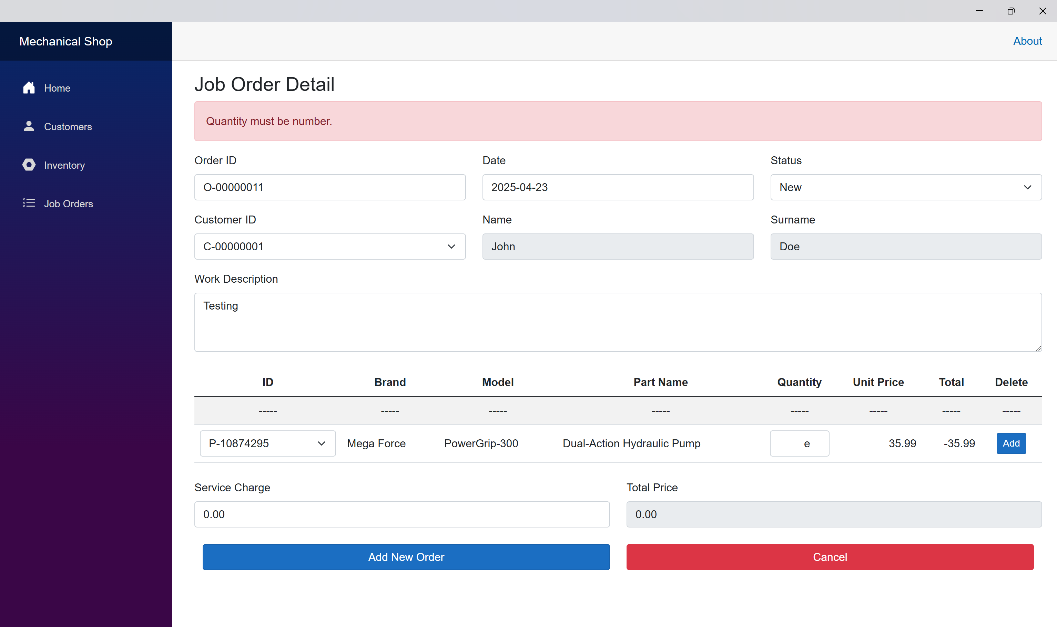

## The added item is in the list.

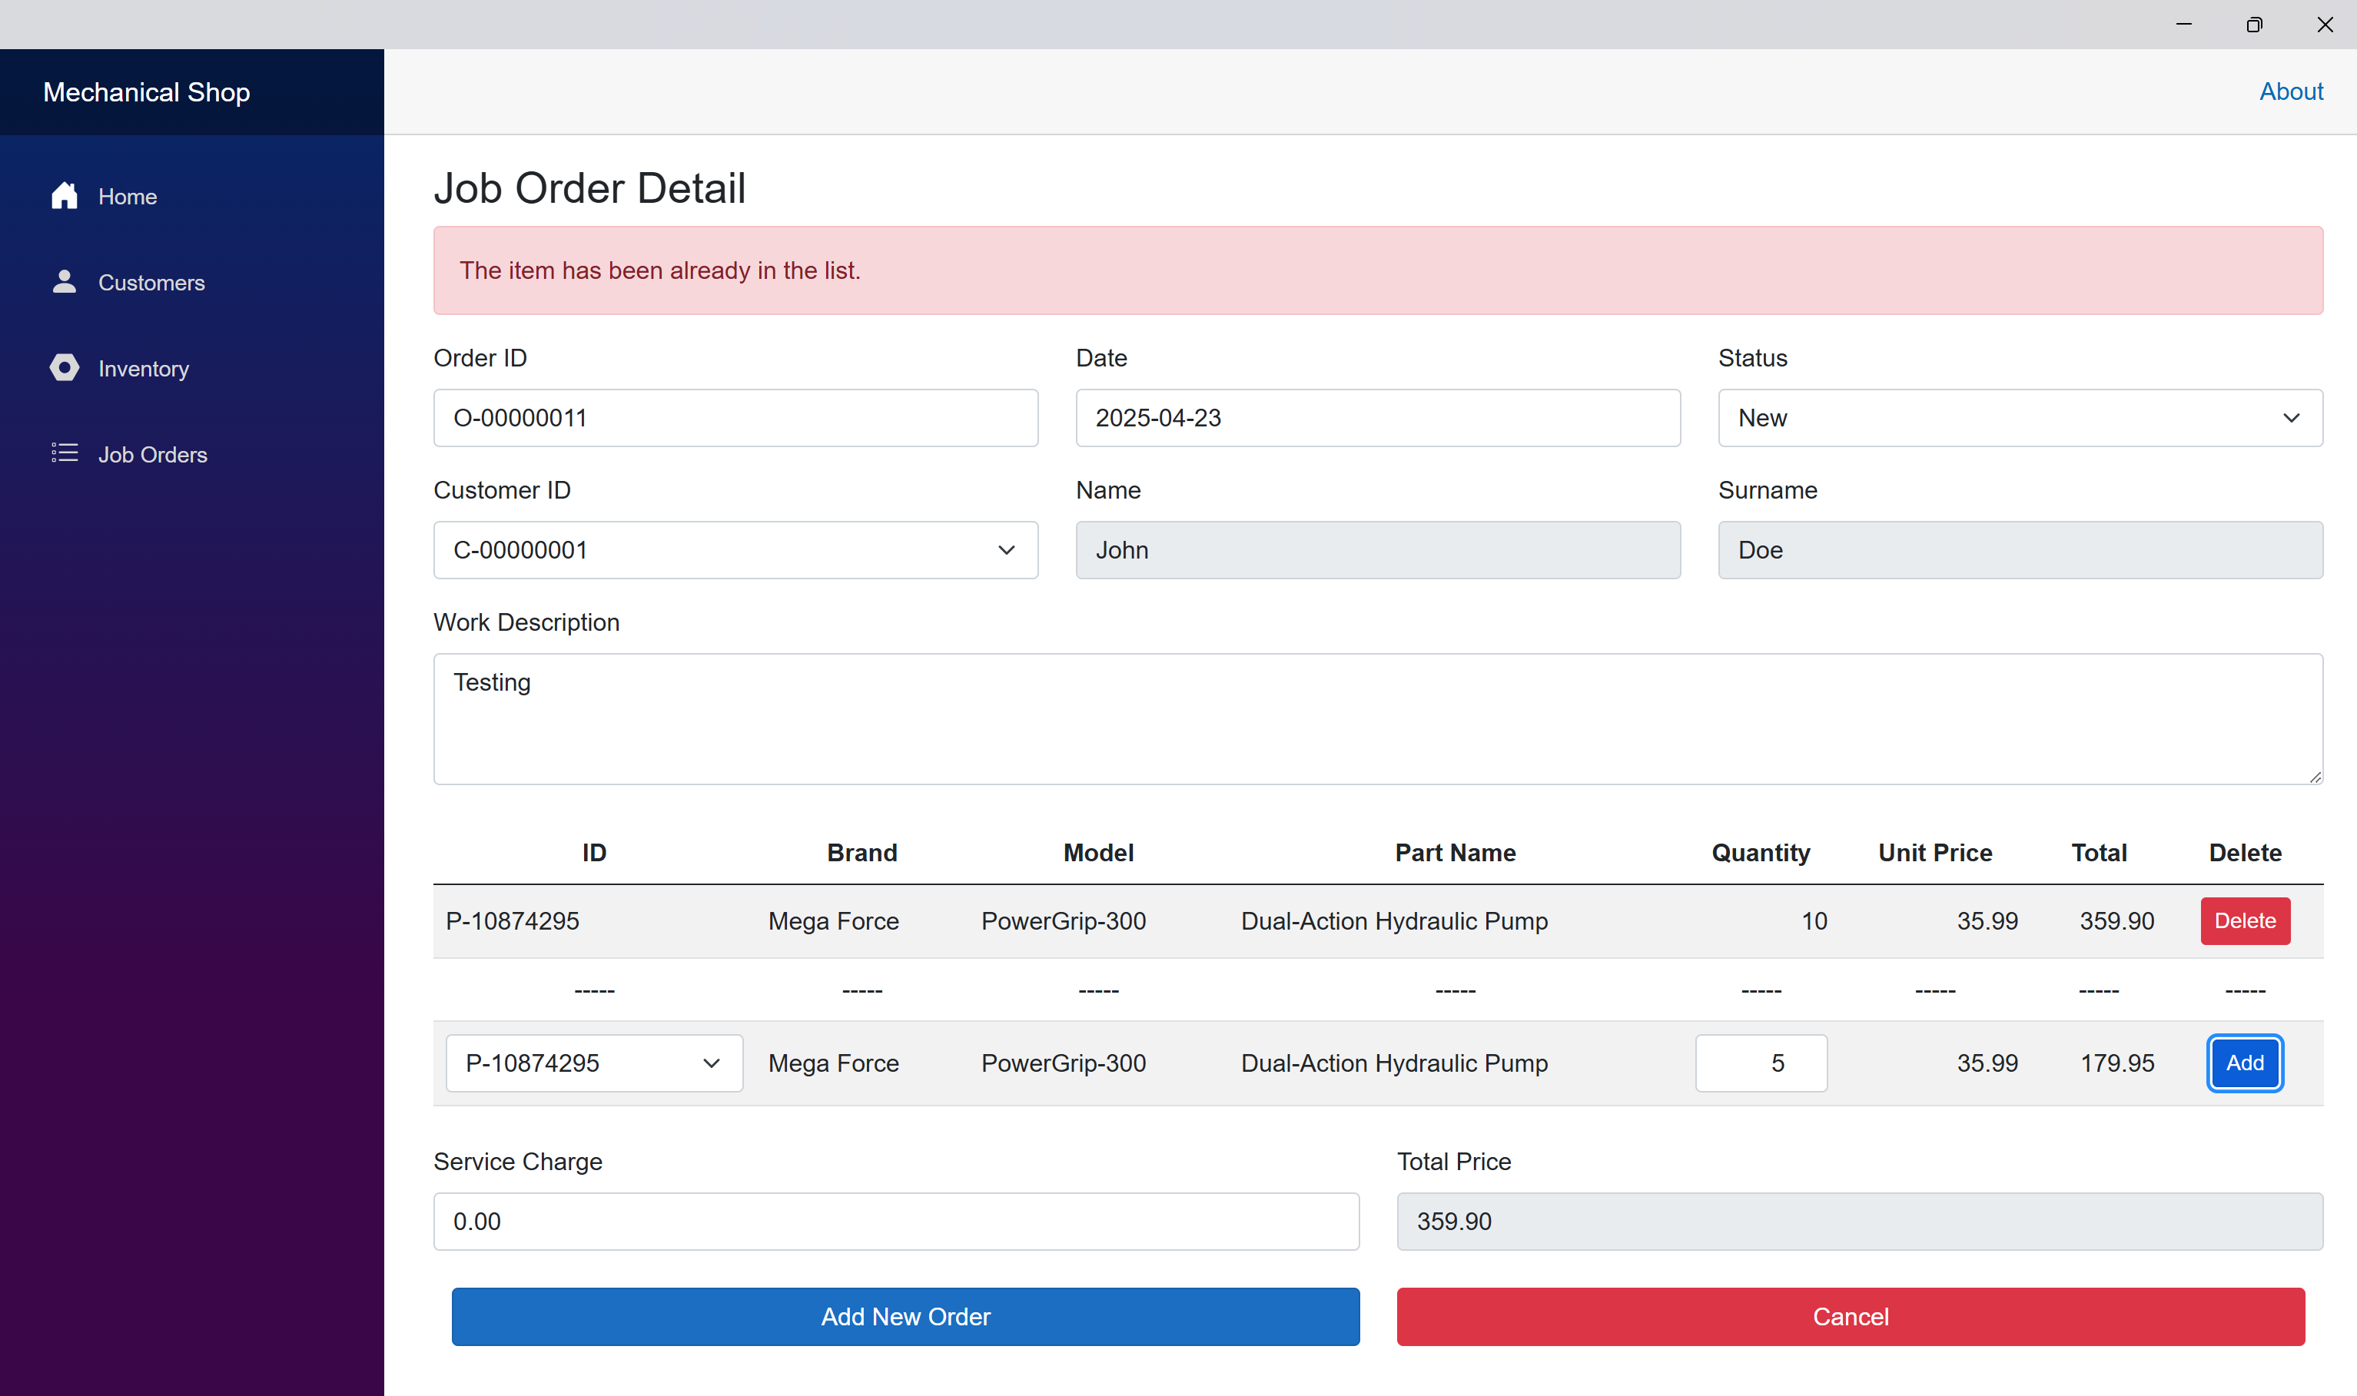

## The quantity of added item is more than the available quantity in inventory.

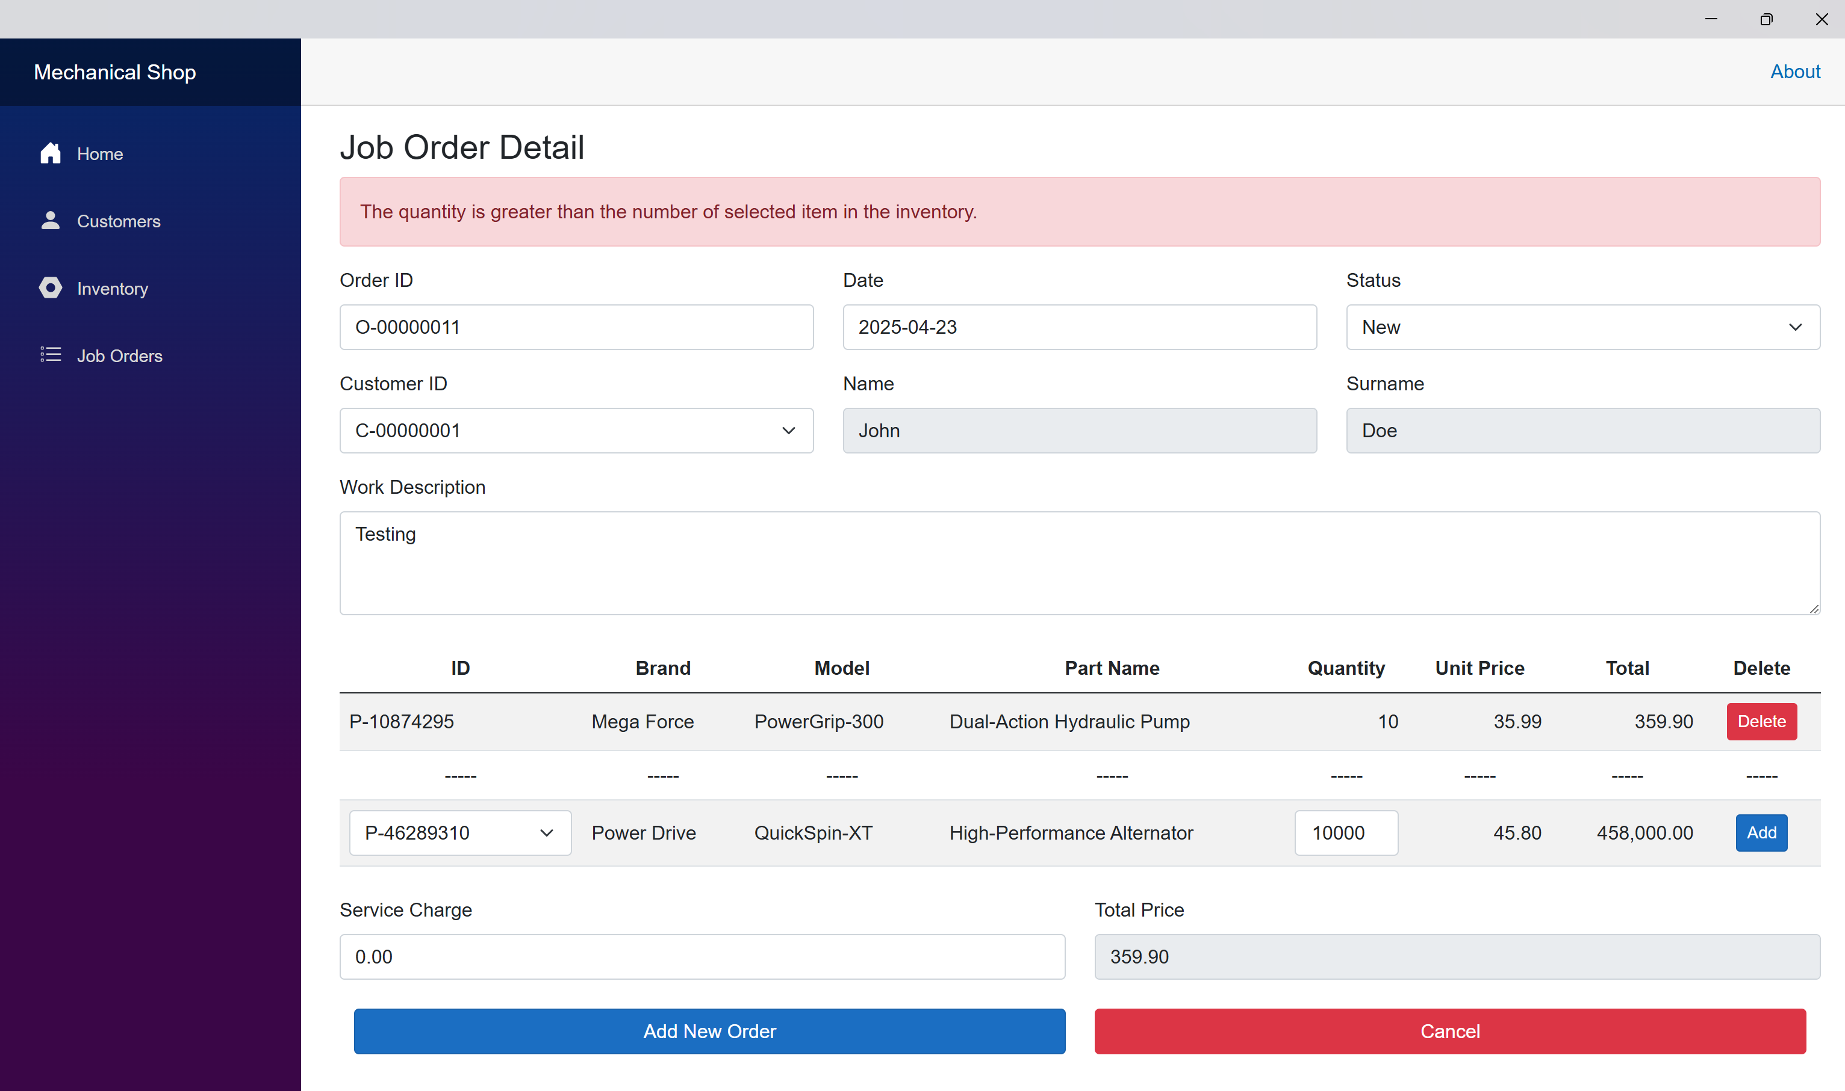

## Service charge is a negative number.

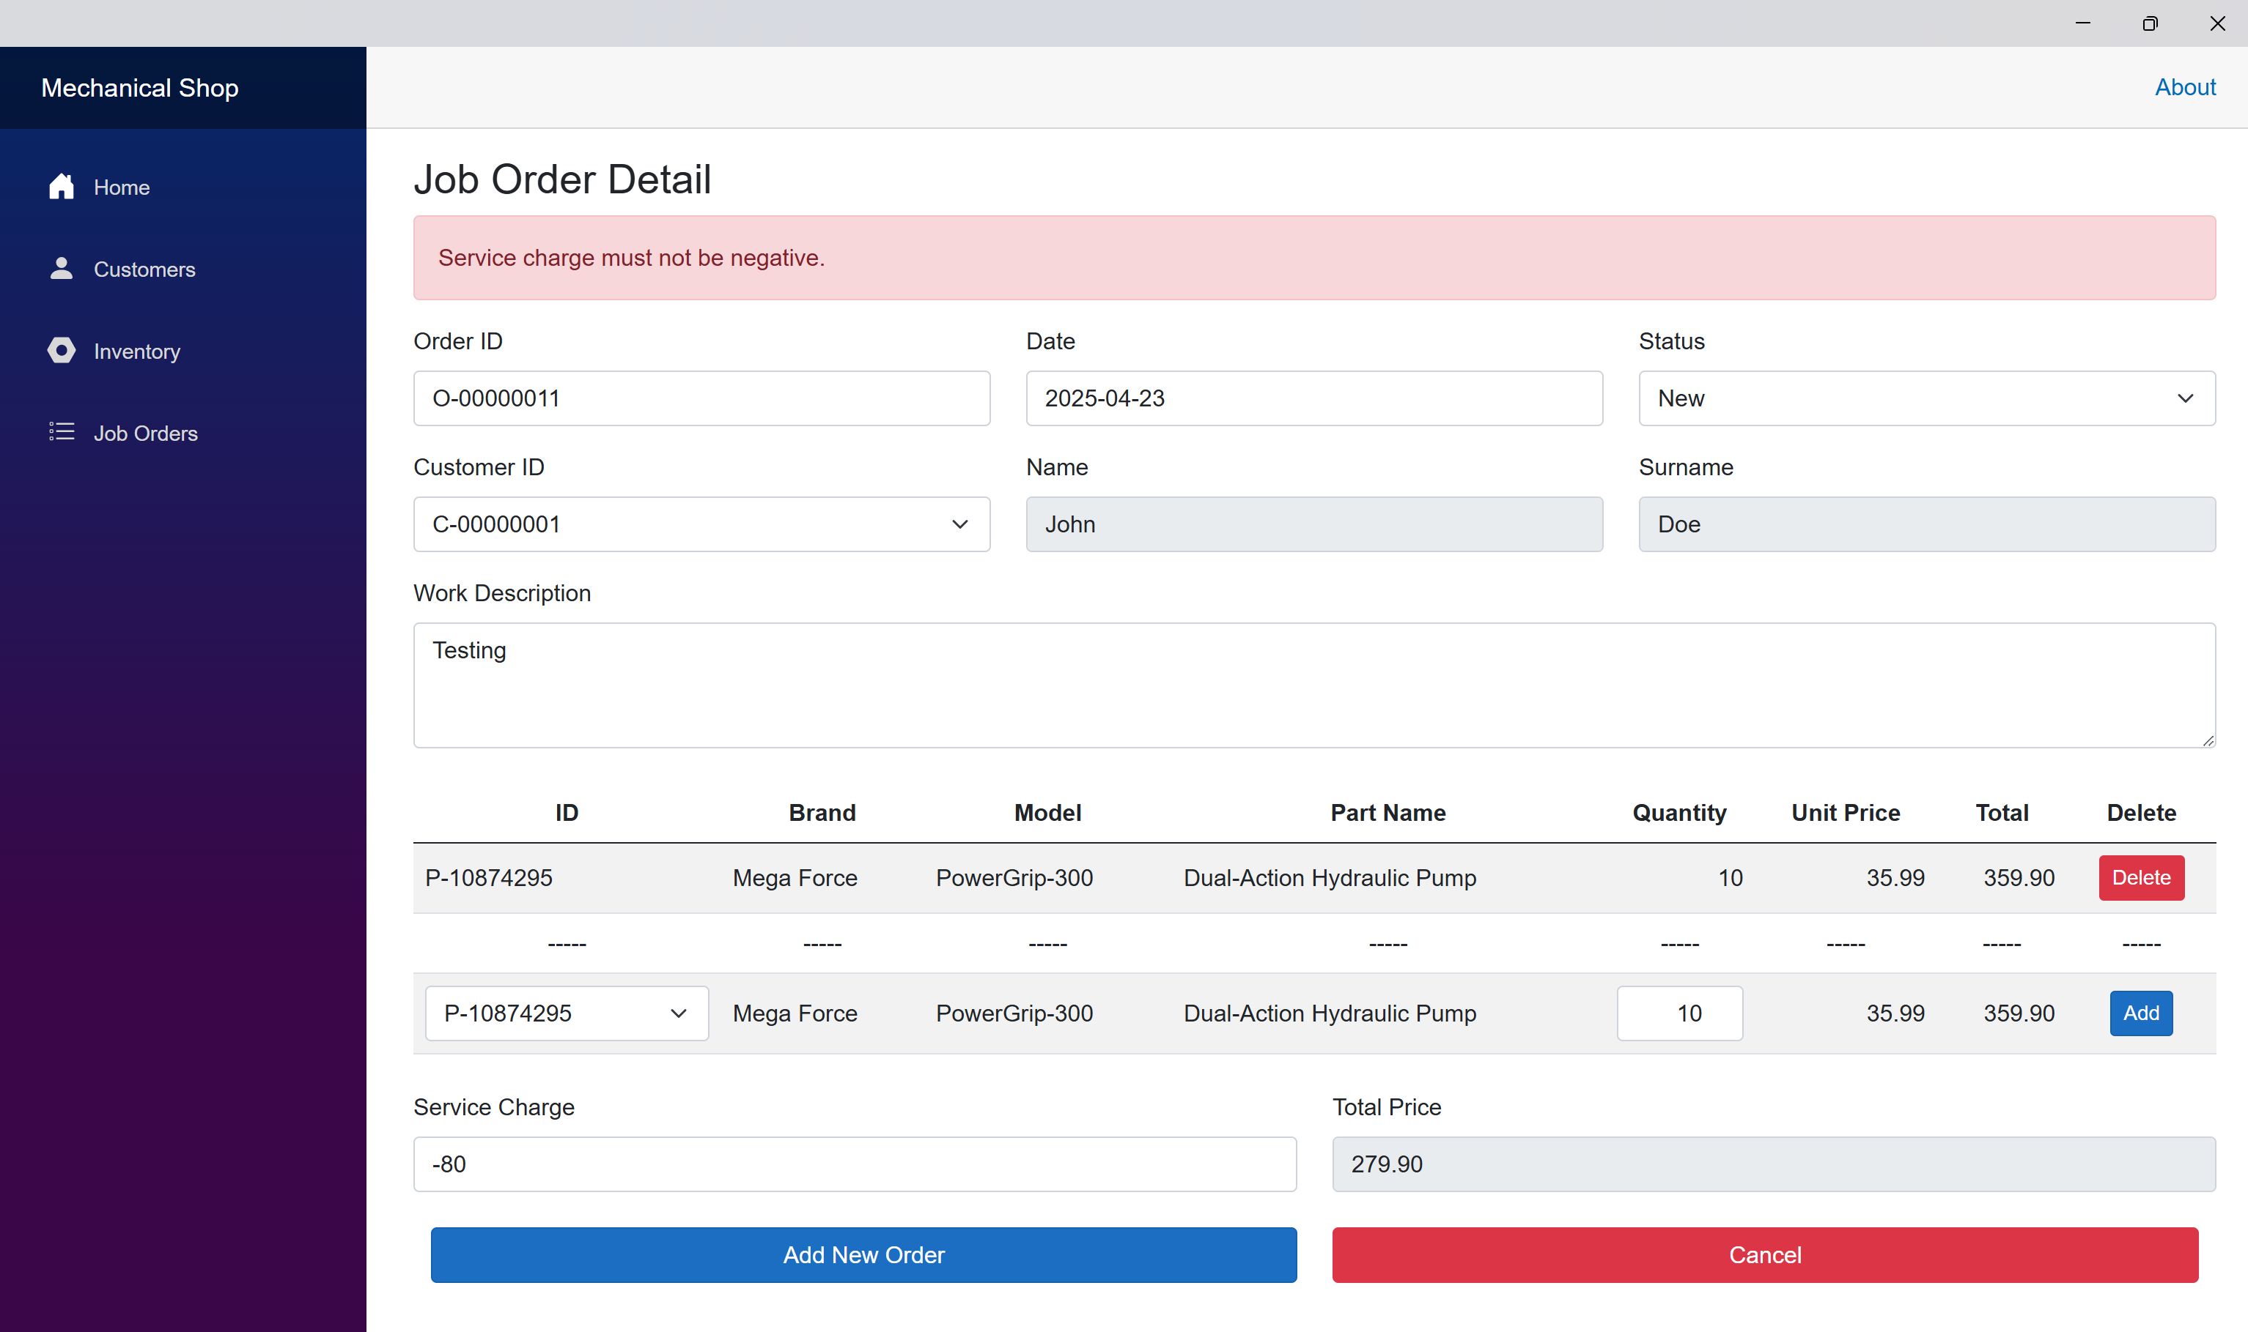

## Service charge is not a number.

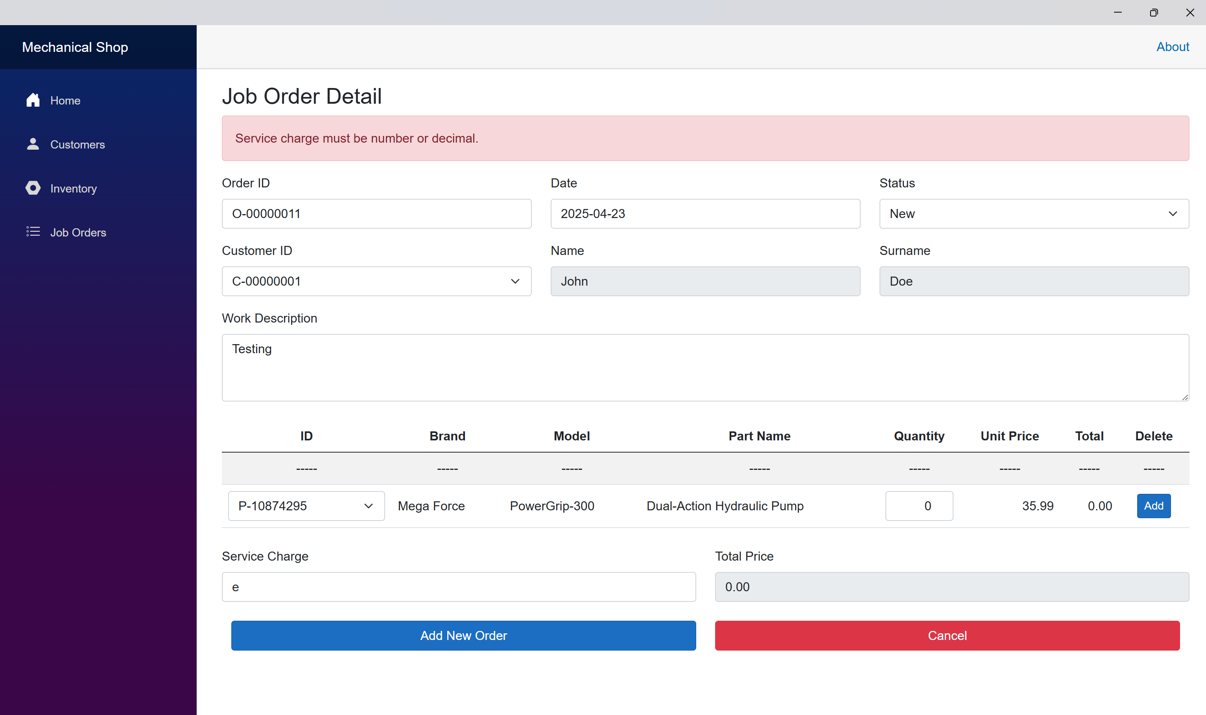

## Add order while other alert message is showing.

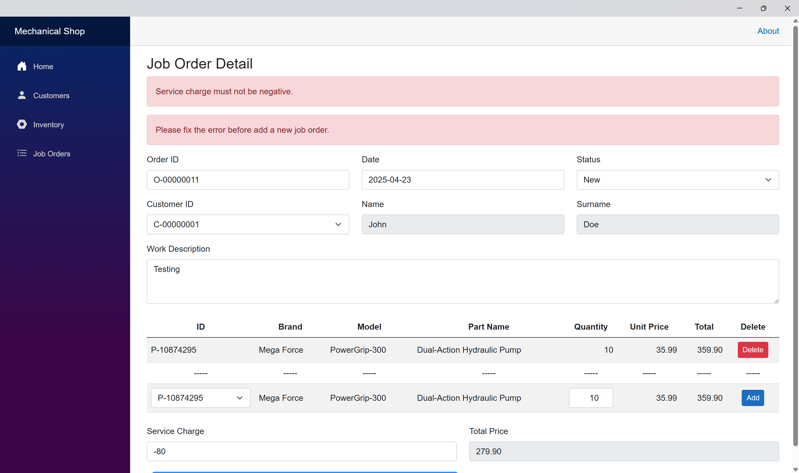

## Add a new order while no customer or no part in the database.

